cid:image001.png@01D55DCE.799212C0

**LIVENT_IT Infra_Azure Cloud_Run Book_Draft Ver 1.0**

**Service Transition Run book KPMG**



**LIVENT_IT Infra_Cloud_Run Book_Draft Ver 1.0**

**Chetan Talwar**

**KPMG**

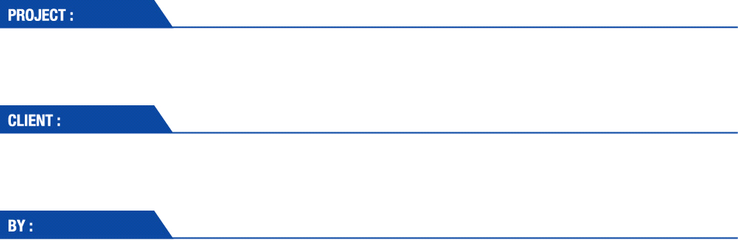

**Chetan Talwar**

**KPMG**

**LIVENT - FMC Lithium USA Corp**

**Vinodh Sivashanmugam/Ramesh/ Vinod BS /Sangeetha/ Kiran MB**

Document Information

|  |  |  |  |
| --- | --- | --- | --- |
| Project Name: | **LIVENT - FMC Lithium USA Corp** | | |
| Transition Director :  Transition Manager: |  | Document Version No: | 1 |
| Service Delivery Manager: |  |  |  |
| Prepared By: | **Vinodh Siva/ Ramesh/ Vinod BS /Sangeetha/ Kiran** | Preparation Date: |  |
| Reviewed By: |  | Review Date: |  |

Version History

| Ver. No. | Ver. Date | Revised By | Description | Filename |
| --- | --- | --- | --- | --- |
| 1 | 29th August 2019 |  | Livent Cloud Run Book | LIVENT_IT Infra_Cloud_Run Book_Draft Ver 1.0 |
|  |  |  |  |  |
|  |  |  |  |  |
|  |  |  |  |  |

cid:image001.png@01D55DCE.799212C0

cid:image001.png@01D55DCE.799212C0

Table of Contents

1. Document Objective 5

2. Signed SOW 5

3. Document Repository 5

4. Operational Support Hours 5

5. SLA 5

6. Business Overview 6

7. In Scope and Out of Scope Activities 6

7.1. In Scope for Managed Services 6

7.2. Out of Scope for Managed Services 6

8. High Level Architecture Diagram 7

8.1. Secure Internet Communication 8

9. Azure Subscription Structure 9

10. Licensing 9

11. Azure Regions and Licensing 10

12. Server Naming Standards 10

13. Resource Tagging 11

14. Server Commissioning Process/Decommissioning Process 12

15. Application Specific Inputs 14

16. Monitoring Parameters and Thresholds 14

17. VM Families and Tiers 14

18. Server Master Inventory Details 14

19. Disaster Recovery Management 14

19.1. Disaster Recovery/Backup Design 14

20. Account Details 15

21. Network Component Details 15

22. Resource Group Specification 22

23. High Availability 25

23.1. Availability Set 25

24. Load Balancer 27

24.1. External Load Balancer 27

24.2. Internal Load Balancer 28

24.3. High Availability Specification 28

24.4. SQL Server Database Disaster Recovery 32

24.5. SAP HANA System Replication (HSR) 32

25. Storage Component Details 33

26. Risk Register 34

27. Security 34

27.1. Network Design 35

27.2. Identity, Access and Authorization 35

27.3. Encryptions 35

28. Firewall Design 35

28.1. Next Gen Firewall 35

28.2. Web Application Firewall 36

29. MFA – Multi Factor Authentication 37

30. Server Patch Management 37

31. Maintenance Window 38

32. Backup Management 39

32.1.1. VM Backup 39

33. Approval and Communication 43

33.1. Type of Update 43

34. Antivirus Management 44

35. Active Directory and DNS Server Management 44

35.1. AD Users 44

35.2. AD Groups 44

36. Incident Management Process 45

37. Change Management Process 45

38. Problem Management Process/ RCA Process 45

39. On-Boarding/Off-Boarding Process 45

3. Escalation Matrix 45

40. Vendor Management 46

41. Appendix 46

Assessment Observations 46

# Document Objective

Objective of this document is to portray the "Livent Corp USA" environment hosted on Azure cloud in US EAST 2 and DR on US WEST 2. This run book will be a used as a base guide by the COGNIZANT offshore Elastic Operations teams for steady state operations.

# Signed SOW

Elastic Operations team Standard SOW attached for reference. Pease refer in scope and out of scope services.

# Document Repository

All the documents are stored in: SharePoint link

<https://livent.sharepoint.com/sites/ManagedServices/Shared%20Documents/Forms/AllItems.aspx>

# Operational Support Hours

Platinum support 24x7

# SLA

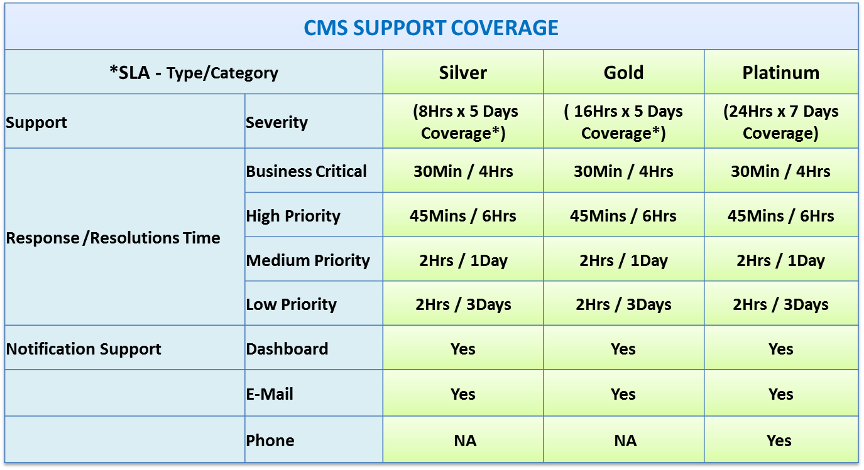

# Business Overview

Livent has been harnessing lithium’s potential to change the energy landscape. Livent meets the most demanding technical requirements, driven by our high-performance product solutions, industry-leading material science expertise, fully integrated supply chain, and passion for excellence.

# In Scope and Out of Scope Activities

**Livent’s** Application deployment and management will be handled by Application team along with FMC team.

# In Scope for Managed Services

Managing the following are the major pointer that would be CMS in-scope:

* Compute – Azure VM.
* Storage – Managed & Unmanaged Disk, Azure blob storage and Azure File Share monitoring.
* Networking – Azure VPN, Load balancer, Traffic Manager and Public/Private IPs m.
* Administration & Security – Azure NSG and UDRs.
* VM Connectivity
* Virtual Instance Administration
* Network and MSSQL Management

# Out of Scope for Managed Services

* LAN infrastructure hardware, cabling & local PBX Support.
* Wireless AP hardware Support.
* Desktop Support for Site apart from 2 Locations (Philadelphia and Ewing, NJ)
* Local Application, local Server Support and Administration.
* Hardware replacement and maintenance renewals (Access Points, Switches, Server Firewalls)
* Asset Inventory Management & Release Management.
* End to End release management for Desktop Services.
* L2/L3 Network Support & L3 Support for AD management.
* Operating System Upgrades / any sort of Cloud Migrations or Architectural Changes.
* Manual Monitoring (including email monitoring)
* Application Performance Monitoring is out of Scope
* Customized Tool / Reports / Monitoring and Deployment of customer specific tools
* Any Licensing Support on any form
* Application Performance Management / Testing
* Design and Build, Architecture, Application Migration, Platform Up gradation, and Engineering and Architecture.
* Major Operating System upgrades that require larger efforts.
* Vendor SLA Management
* Application Administration and Application Database Administration

# High Level Architecture Diagram

The below diagram depicts the infrastructure architecture on Livent VNET connectivity.



Similar to the reference architecture, the primary network, which is deployed in East US 2, is comprised of a hub VNET but with two spoke VNETs instead of one. One spoke is for non-production SAP and another for non-SAP workloads.

In a hub and spoke topology, all spokes connect to the hub via Azure VNET peering. When two VNETs are peered, the networks appear as one. All services in one VNET are accessible to the other unless specifically blocked by Network Security Groups. Communications between the VNETs are routed through the Microsoft backbone just like traffic within a VNET and is kept private.

The Livent HUB VNET has the following characteristics:

1. The secured integration point to the Internet via a next-generation firewall and web application firewall appliances. The Barracuda CloudGen firewall and WAF have been chosen by Livent for this purpose.
2. The connection point to administrative users outside of the Livent network via a Point-to-Site Gateway.
3. Contains a collection of services shared by other services deployed in the Spokes such as Active Directory domain controllers, SAP Router, Exchange Server and other management services. These services are deployed in their specific subnets.

The spoke VNETs include:

1. Production VNET dedicated for SAP, a Web Dispatcher for Production SAP, Sharepoint, and other production workloads.
2. Non-production VNET for with subnets for SAP sandbox/development, SAP QA, Web Dispatcher for non-production SAP, SharePoint, and other non-production workloads

All subnets must include a route table with next-hop routes to the Barracuda firewalls internal load-balancer IP address. This centralizes the security of outbound internet traffic by the firewalls. Together, the route tables and routes are called User Defined Routing in Azure.

As with the Microsoft reference architecture, the Livent network architecture includes a DR VNET deployed in West US 2. For continuous replication of HANA, the DR and SAP Production VNETs are peered. All production VMs are configured for recovery in DR using ASR. The DR VNET includes subnets for SAP, Sharepoint, non-ERP workloads, and firewalls.

**Note:**

**This current Setup has connectivity between FMC on-premises and Azure Livent Environment will be soon disconnected. Express Route setup will be removed and connectivity to Livent Azure VM’s will be only using Point to Site Connection and ZScalar VPN Gateway.**

# Secure Internet Communication

The network perimeter is secured by a combination of Barracuda CloudGen Firewalls and Web Application Firewalls (WAFs). In the primary site, the FWs and WAFs are deployed in pairs in their respective availability sets and in their own subnets. The FWs and WAFs are configured in high-availability pairs respectively.

All servers that require inbound internet traffic have external IP addresses set up on the External Load Balancer, which the FWs NAT to the internal IPs of the target server. The FW Inbound traffic enters the FWs’ external load balancer public IP address and is forwarded to the primary FW, where in turn it is forwarded to the WAFs for further deep packet inspection, and finally to the destination IP.

As previously mentioned, all outbound traffic is routed to the FW, which has rules to allow traffic to specific resources in the Internet required by the specific workloads. If any workload does not require Internet access, all outbound traffic is blocked for that resource.

# Azure Subscription Structure

The as-built Azure environment and all resources will be contained within a single subscription named “Livent” and there is only Single subscription for all Azure environments and regions.



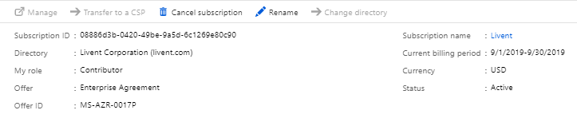

# Licensing

Livent has Microsoft Premier Support, which covers all Microsoft products and cloud services. Use Azure Help and Support to create a ticket for any support required for Azure and Microsoft.

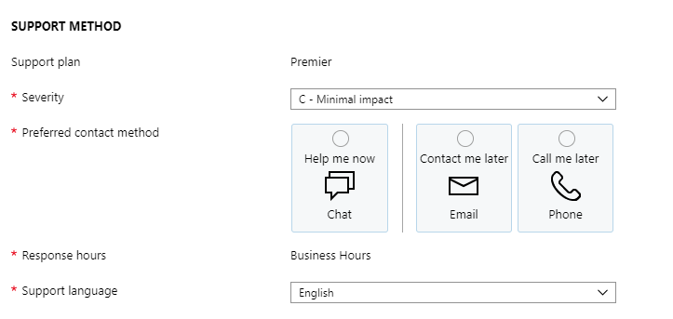

# Azure Regions and Licensing

The HUB, Sandbox, Dev, QA, and Prod VNETs are deployed in US East 2 and the DR VNET deployed in US WEST 2. Azure Resource Groups.

|  |  |  |
| --- | --- | --- |
| Geography | Primary Region | Region Pair |
| North America | US East2 (Virginia) | US Central (Iowa) |

|  |  |  |
| --- | --- | --- |
| Geography | Primary Region | Region Pair |
| North America | US West2 (Washington) | West Central (US) |

# Server Naming Standards

Livent server naming convention is as follows:

|  |  |  |  |  |  |
| --- | --- | --- | --- | --- | --- |
| Application/Usage | | | Env. | Func | |
| A | A | A | E | F | F |

Function

* W – Web Server
* VM – Application Server
* DB – Database Server

Environment

* Prod – Production
* QA – Pre-Prod / QA
* DEV – Development

Enumerator

* Two-digit number 01-99

Examples

* Web server
  + wbdp-dev-vm1 Application server in Development
  + wbdp-prod-vm1 Application server in Prod
  + wbdp-qa-vm1 Application server in Quality
* Database servers
  + ecc-dr-db1- SQL Database in DR
  + ecc-prod-db1- SQL Database in Prod

|  |  |  |
| --- | --- | --- |
| **Entity** | **Suggested Pattern** | **Examples** |
| Resource Group | <service short name>-<environment>-<region abbreviation> | network-prod-reu2; storage-nonprod-reu2 |
| Availability Set | <service-short-name>-<environment>-vm-set | ecc-dev-vm-set; |
| VM | <name>-<env>-vm<number> | sapecc-qa-vm1; sccm-dev-vm1 |
| Storage Account (data) | <globally unique name><number> | sqlbackupdata001; vmsnapshotdata002 |
| Storage Account (disk) | <vm name without hyphens>st<number> | sappiqaappcm1st0; sapbiprodsqlvm2st1 |
| VNET | vnet-<environment>-<region abbreviation> | vnet-prod-reu2 |
| Subnet | <region abbreviation>-<environment>-<purpose> | reu2-prod-sap-data; rwu2-dr-mgmt; reu2-hub-waf-dmz |
| NSG | VM NICs: <region abbreviation>-<vm context>-nsg | VM Nic: reu2-waf-nsg |
| Subnets: <subnet name>-nsg | Subnet: reu2-prod-sap-data-nsg |
| NSG Rule | <descriptive context> | sapbi-allow; saphana-deny sccm-allow |
| NIC | <vmname>-nic0<num> | sappi-qa-app-vm1-nic01; sapbi-prod-sql-vm2-nic01 |
| LB | Internal load balancer: <region abbreviation>-<environment>-<short vm abbreviaton>-ilb<number> | rwu2-dr-fw-elb1; reu2-hub-waf-ilb1 |
| External load balancer: <region abbreviation>-<environment>-<short vm abbreviaton>-elb<number> |
| Gateways | <region abbreviation>-<gateway type abbreviation>-gateway | rwu2-p2s-gateway; reu2-er-gateway |
| Express Route Circuit Connections | <region abbreviation>-<gateway type abbreviation>-connection | rwu2-er-connection |

# Resource Tagging

Tags provide a way to logically organize resources with custom properties and can be applied to resource groups and/or directly to individual resources. Tags can be used to refine the selection criteria for resources or resource groups from the console, web portal, PowerShell, or the Azure resource API. Tags are particularly useful when you need to organize resources for billing or management.

|  |  |  |  |  |
| --- | --- | --- | --- | --- |
| **Tag Name** | **State** | **Description** | **Tag Value** | **Example** |
| App Taxonomy | Required | Provides information on who owns the resource group and what purpose it serves within their application | Org\App\Environment | USOPS\Finance\Payroll\PayrollTestEnv1 |
| Environment Type | Required | Provides information on what the resource group is used for (useful for maintenance, policy enforcement, chargeback, etc.) | Dev, Test, UAT, Prod | Test |
| Billing Identifier | Required | Provides a charge code or cost center to attribute the bill for the resources too | Cost Center | 34821 |
| Maintenance Window | Optional | Provides a window during which patch and other impacting maintenance can be performed | Window in UTC "day:hour:minute-day:hour:minute" | Tue: 04:00-Tue: 04:30 |
| ExpirationDate | Optional | Provides a date when the environment is expected to be removed by so that reporting can be done to confirm if an environment is still needed. | Expiration Date in UTC | 2016-06-15T00:00:00 |

# Server Commissioning Process/Decommissioning Process

In order to build/decom a new VM in Azure environment, Respective application team will raise a SR and fill the below respective qualification checklist to proceed further.

* 1. **Server** **Commissioning**

Application / Server Owner should fill below the qualification checklist and drop a mail to Cognizant Cloud Manage team.



**13.1.1 Process to follow for server commissioning**

* 1. Send a mail to CCSCMSSecondary(Cognizant) [CCSCMSSecondary@cognizant.com](mailto:CCSCMSSecondary@cognizant.com)

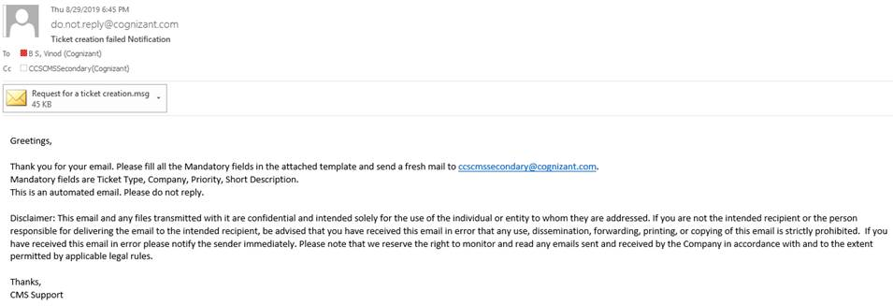

* 1. You will receive an bounce back mail with below template format

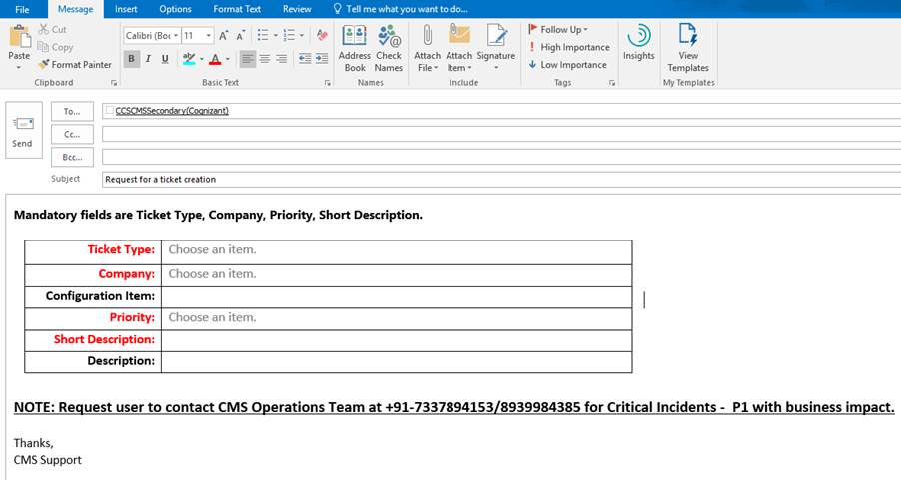

* 1. Fill the above template with server build checklist and resend to [CCSCMSSecondary@cognizant.com](mailto:CCSCMSSecondary@cognizant.com)
  2. You will receive an email with Service Now ticket #.
  3. **Server Decommissioning**

Application / Server Owner should fill below the qualification checklist and drop a mail to Cognizant Cloud Manage team.

1. Verify the resources attached to the resource group which you will be deleting.
2. Verify the data disks attached to the server
3. Once you make sure all necessary approvals are in place, delete the server
   1. Once the server is deleted, update change ticket with following tasks
4. Task for Service Management to update the CI list
5. Task for Monitoring team to remove server from monitoring



# Application Specific Inputs

Custom scripts are there: Pending session with Application team, post which we will update this.

# Monitoring Parameters and Thresholds



# VM Families and Tiers

Virtual machines are the fundamental compute resource in Azure (App Service is an example of another compute resource) providing what’s known as infrastructure as a service (IaaS).

There are dozens of unique VM instance sizes and selecting the correct size for an application is an important component in the effective use of Azure IaaS services.

**Note**: VM’s size used are mentioned in Inventory Details.

# Server Master Inventory Details



# Disaster Recovery Management

# Disaster Recovery/Backup Design

Azure Site Recovery (ASR) will be used for DR of Production Environment workloads. ASR service contributes to business continuity and disaster recovery (BCDR) strategy by keeping business apps up and running, during planned and unplanned outages. ASR manages and orchestrates disaster recovery including replication, failover, and recovery.

Note: - DR Drill Artifacts prepared by Accenture Transition Team are yet to be received.

# Account Details

Root account e-mail id is acpapi@livent.onmicrosoft.com. Multi Factor Authentication is setup for root account using *****. Following team members have access to root credentials:

Note: - Need to verify with Jerry Wiernasz.

# Network Component Details

This chapter describes the final Azure network design.

* 1. **VNET**

Following are VNETs in US EAST2 and US West2 region:

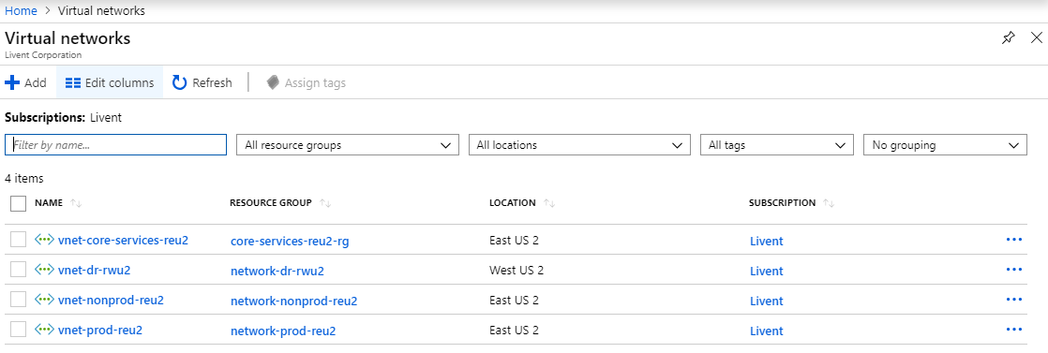

* 1. **Subnet Details**

On Core VNET vnet-core-services-reu2, 6 Subnets are configured.

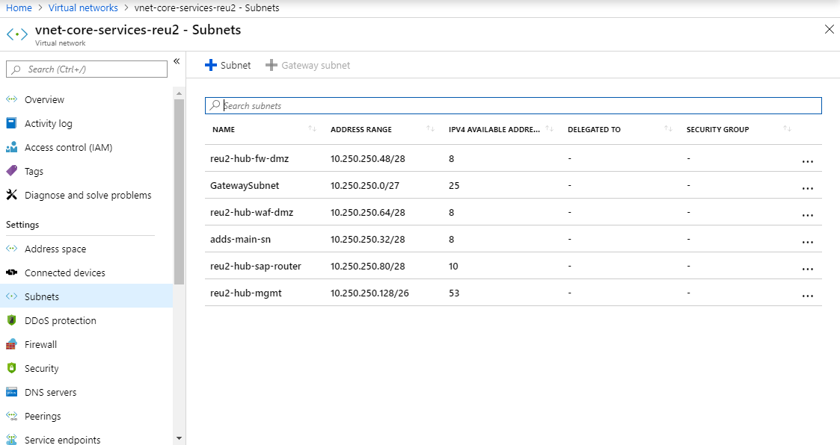

On DR VNET vnet-dr-rwu2, 11 Subnets are being configured.

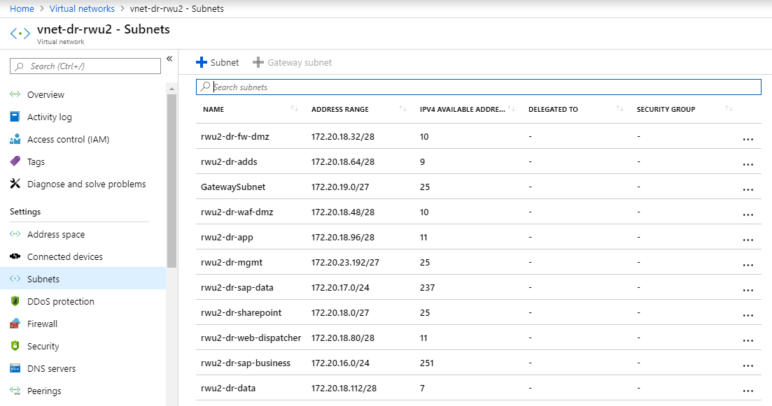

On Production VNET-PROD-reu2, 7 Subnets are being configured.

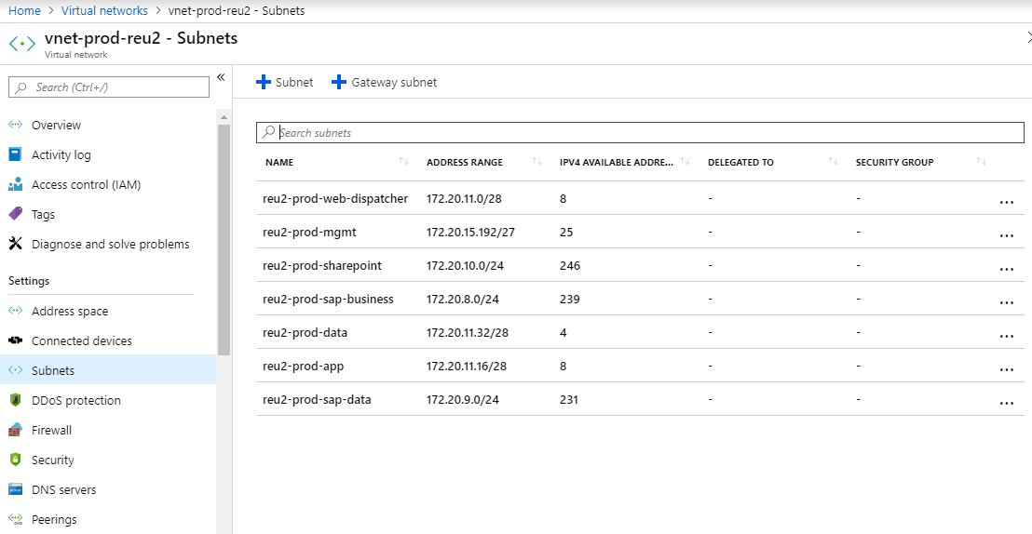

On Non-prod VNET VNET-NONPROD-reu2, 6 Subnets are being configured and used.

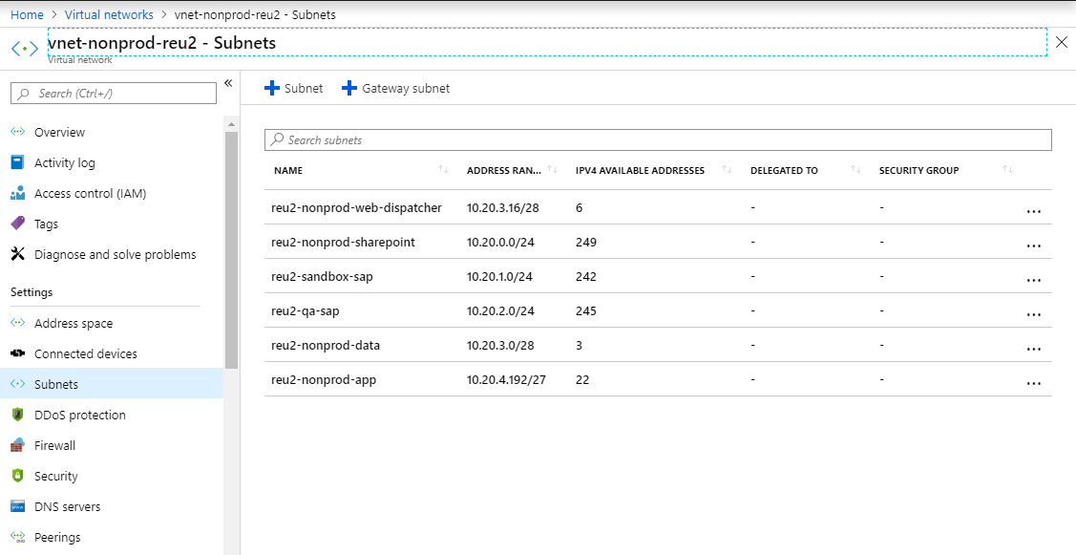

* 1. **UDR Details**

Subnet based UDR Rules has been configured.

|  |  |  |  |  |
| --- | --- | --- | --- | --- |
| Sl.No | **Route IP** | **UDR – Rule Name** | **Connecting Subnet** | **Device Name (Barracuda Firewall Device Name)** |
| 1 | 172.20.18.36 | adds-dr-rwu2-rtl - Routes | rwu2-dr-adds | fw-dr-vm01 |
| 2 | 10.250.250.54 | adds-hub-reu2-rtl - Routes | adds-main-sn | reu2-dmz-fw-ilb1 |
| 3 | 172.20.18.36 | app-dr-rwu2-rtl - Routes | rwu2-dr-app | fw-dr-vm01 |
| 4 | 10.250.250.54 | app-nonprod-reu2-rtl - Routes | reu2-nonprod-app | reu2-dmz-fw-ilb1 |
| 5 | 10.250.250.54 | app-prod-reu2-rtl - Routes | reu2-prod-app | reu2-dmz-fw-ilb1 |
| 6 | 172.20.18.36 | data-dr-rwu2-rtl | rwu2-dr-data | fw-dr-vm01 |
| 7 | 10.250.250.54 | data-nonprod-reu2-rtl | reu2-nonprod-data | reu2-dmz-fw-ilb1 |
| 8 | 10.250.250.54 | data-prod-reu2-rtl | reu2-prod-data | reu2-dmz-fw-ilb1 |
| 9 | 172.20.18.36 | mgmt-dr-rwu2-rtl | rwu2-dr-mgmt | fw-dr-vm01 |
| 10 | 10.250.250.54 | mgmt-hub-reu2-rtl | reu2-hub-mgmt | reu2-dmz-fw-ilb1 |
| 11 | 10.250.250.54 | mgmt-prod-reu2-rtl | reu2-prod-mgmt | reu2-dmz-fw-ilb1 |
| 12 | 10.250.250.54 | qa-sap-nonprod-reu2-rtl | reu2-qa-sap | reu2-dmz-fw-ilb1 |
| 13 | 172.20.18.36 | sap-busines-dr-rwu2-rtl | rwu2-dr-sap-business | fw-dr-vm01 |
| 14 | 10.250.250.54 | sap-business-prod-reu2-rtl | reu2-prod-sap-business | reu2-dmz-fw-ilb1 |
| 15 | 172.20.18.36 | sap-data-dr-rwu2-rtl | rwu2-dr-sap-data | fw-dr-vm01 |
| 16 | 10.250.250.54 | sap-data-prod-reu2-rtl | reu2-prod-sap-data | reu2-dmz-fw-ilb1 |
| 17 | 10.250.250.54 | saprtr-hub-reu2-rtl |  | reu2-dmz-fw-ilb1 |
| 18 | 10.250.250.54 | sbx-sap-nonprod-reu2-rtl | reu2-sandbox-sap | reu2-dmz-fw-ilb1 |
| 19 | 172.20.18.36 | shrpt-dr-rwu2-rtl | rwu2-dr-sharepoint | fw-dr-vm01 |
| 20 | 10.250.250.54 | shrpt-nonprod-reu2-rtl | reu2-nonprod-sharepoint | reu2-dmz-fw-ilb1 |
| 21 | 10.250.250.54 | shrpt-prod-reu2-rtl | reu2-prod-sharepoint | reu2-dmz-fw-ilb1 |
| 22 | 10.250.250.52 | waf-dmz-reu2-rtl | reu2-hub-waf-dmz | fw-hub-vm01 |
| 23 | 172.20.18.36 | waf-dmz-rwu2-rtl | rwu2-dr-waf-dmz | fw-dr-vm01 |
| 24 | 172.20.18.36 | webdisp-dr-rwu2-rtl | rwu2-dr-web-dispatcher | fw-dr-vm01 |
| 25 | 10.250.250.54 | webdisp-nonprod-reu2-rtl | reu2-nonprod-web-dispatcher | reu2-dmz-fw-ilb1 |
| 26 | 10.250.250.54 | webdisp-prod-reu2-rtl | reu2-prod-web-dispatcher | reu2-dmz-fw-ilb1 |

* 1. **Azure NSG Rules Assigned**

Network Security Group (NSG) allow or deny network traffic to resources connected to Azure Virtual Networks (VNet).    NSGs secure both inbound and outbound access in the same way that a traditional firewall would function.  NSG rules are defined with a standard five-tuple definition (source IP(s), source port, destination IP(s), destination port, protocol).  The NSG can be configured in below ways.

* NSGs can be attached to NIC.
* NSGs can be attached to Subnets.

With Livent NSG’s are associated with NIC

|  |  |  |  |  |  |  |  |
| --- | --- | --- | --- | --- | --- | --- | --- |
| **S.No** | **Name** | **Location** | **VM** | **Rule Name** | **Allow Inbound Rule** | | |
| **Source CIDR** | **Port** | **Protocol** |
| 1 | docave-prod-vm1-nsg | East US 2 | docave-prod-vm1101 |  | * | 3389 | TCP |
| 2 | fw-reu2-nsg | East US 2 | fw-hub-vm01& fw-hub-vm02 | Port_Allow_IN | * | * | * |
| 3 | fw-rwu2-nsg | West US 2 | fw-dr-vm01 | Port_All_IN | * | * | * |
| 4 | reu2-fw-nsg | East US |  | Port-All-In | * | * | * |
| 5 | reu2-hub-saprtr-nsg | East US 2 | rtr-prod-private | AllowSapInbound3299 | * | 3389 | * |
| 6 | reu2-nonprod-web-dispatcher-nsg | East US 2 |  | AllowInbound-reu2-hub-waf-dmz | 10.250.250.64/28 | * | * |
|  |  |  |  | AllowInbound-reu2-hub-sap-router | 10.250.250.80/28 | * | * |
|  |  |  |  | AllowInbound-reu2-nonprod-app | 10.20.4.192/27 | * | * |
|  |  |  |  | AllowInbound-adds-main-sn | 10.250.250.32/28 | * | * |
|  |  |  |  | AllowInbound-reu2-prod-web-dispatcher | 172.20.11.0/28 | * | * |
|  |  |  |  | AllowRDP | VirtualNetwork | 3389 | * |
|  |  |  |  | DenyAllVirtualNetworkInbound | VirtualNetwork | * | * |
| 7 | reu2-prod-bus-nsg | East US 2 |  |  |  |  |  |
| 8 | reu2-prod-web-dispatcher-nsg | East US 2 |  | AllowInbound-reu2-hub-waf-dmz | 10.250.250.64/28 | * | * |
|  |  |  |  | AllowInbound-reu2-hub-sap-router | 172.20.8.0/24 | * | * |
|  |  |  |  | AllowInbound-reu2-prod-app | 172.20.11.16/28 | * | * |
|  |  |  |  | AllowInbound-adds-main-sn | 10.250.250.32/28 | * | * |
|  |  |  |  | AllowInbound-reu2-nonprod-web-dispatcher | 10.20.3.16/28 | * | * |
|  |  |  |  | AllowRDP | VirtualNetwork | 3389 | * |
|  |  |  |  | DenyAllVirtualNetwork | VirtualNetwork | * | * |
| 9 | reu2-waf-nsg | East US 2 | waf-hub-vm01 & waf-hub-vm02 | Port_All_IN | * | * | * |
| 10 | rwu2-waf-nsg | West US 2 | waf-dr-vm1 | Port_All_IN | * | * | * |
|  |  |  |  | Port_8000 | * | 8000 | * |
|  |  |  |  | Port_8080 | * | 42832 | * |

* 1. **Gateway Details**

Two Azure VPN connections are in use. One is for Livent, private MPLS circuits using ExpressRoute from AT&T cross-connect to Azure ExpressRoute Gateways in the HUB and DR VNETs.

The other is the point-to-site VPN connections for External Users to Azure P2S VPN Gateways in the HUB and DR VNETs.

Zscalar is the point-to-site VPN software used for this purpose. Cognizant will be leveraging this post transition

Note: - Express **Route Connection between FMC on premises and Livent Azure Cloud will be disconnect. Only Point to Site and Zscalar VPN will be used for remote connectivity.**

Overall, there will be two ExpressRoute Gateway and corresponding circuits in East US 2 and West US 2. Likewise, there will be two VPNs, one for each region.

* 1. **Express Route Specification**

AT&T NetBond will be the ExpressRoute Service Provider.

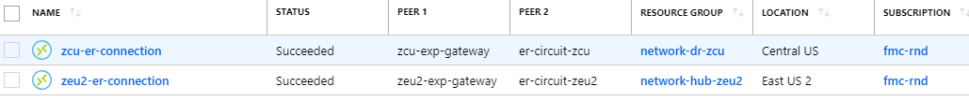

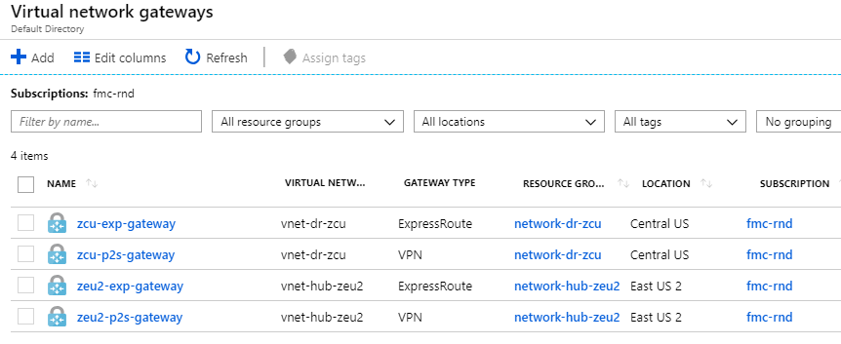

The corresponding ExpressRoute circuit.

|  |  |  |  |  |  |
| --- | --- | --- | --- | --- | --- |
| Peering Location | Gateway Connection | ExpressRoute  Gateway Name | Circuit Name | SKU Tier | SKU Family |
| Washington DC | zeu2-exp-gateway | zeu2-exp-gateway | er-circuit-zeu2 | Standard | MeteredData |
| Chicago | zcu-exp-gateway | zcu-exp-gateway | er-circuit-zcu | Standard | MeteredData |

**Note: Express Route Connection will be removed soon.**

* 1. **Point to Site VPN Specification**

|  |  |  |  |  |  |
| --- | --- | --- | --- | --- | --- |
| Gateway Location | VNET | Gateway Name | VPN Type | Sku | P2S Address Pool |
| East US 2 | vnet-zeu2 | zeu-vpn1-gateway | RouteBased | VpnGw1 | 192.168.234.0/27 |
| Central US | vnet-zcu | zwu-vpn2-gateway | RouteBased | VpnGw1 | 192.168.235.0/27 |

# Resource Group Specification

|  |  |  |
| --- | --- | --- |
| Resource Group Name | Location | Description |
| appgrp-dev-bw-reu2 | eastus2 | Application Resource Group Development Environment East US 2 |
| appgrp-dev-net-reu2 | eastus2 | Dotnet Application Resource Group Development Environment East US 2 |
| appgrp-dev-sap-reu2 | eastus2 | SAP Resource Group Development Environment East US 2 |
| appgrp-dev-sapdata-reu2 | eastus2 | SAP Resource Group Development Environment East US 2 |
| appgrp-dr-net-rwu2 | westus2 | Dotnet Application Resource Group Environment WEST US 2 |
| appgrp-dr-sapdata-rwu2 | westus2 | SAP Resource Group Environment WEST US 2 |
| appgrp-dr-sharepoint-rwu2 | westus2 | Sharepoint DR WestUS2 |
| appgrp-dr-sharepointdata-rwu2 | westus2 | Sharepoint Data DR WestUS2 |
| appgrp-hub-print-reu2 | eastus2 | Exchange Hub Resource Group EASTUS2 |
| appgrp-hub-print-reu2-asr | westus2 | Exchange Hub Resource Group ASR WESTUS2 |
| appgrp-prod-exch-reu2 | eastus2 | Exchange Production Resource Group EASTUS2 |
| appgrp-prod-net-reu2 | eastus2 | Donet Application Resource Group EASTUS2 |
| appgrp-prod-net-reu2-asr | westus2 | Donet Application Resource Group ASR WESTUS2 |
| appgrp-prod-netdata-reu2 | eastus2 | Donet Data Resource Group EASTUS2 |
| appgrp-prod-netdata-reu2-asr | westus2 | Donet Data Resource Group ASR WESTUS2 |
| appgrp-prod-sap-reu2 | eastus2 | SAP Production Resource Group EASTUS2 |
| appgrp-prod-sap-reu2-asr | westus2 | SAP Production Resource Group ASR WESTUS2 |
| appgrp-prod-sap-reu2-asr-1 | eastus2 | SAP Production Resource Group ASR EASTUS2 |
| appgrp-prod-sapdata-reu2 | eastus2 | SAP Data Production Resource Group EASTUS2 |
| appgrp-prod-sapdata-reu2-asr | westus2 | SAP Data Production Resource Group ASR EASTUS2 |
| appgrp-prod-sapdataqrm-reu2 | eastus2 | SAP Production Resource Group EASTUS2 |
| appgrp-prod-sccm-reu2 | eastus2 | SCCM Application Production Resource Group EASTUS2 |
| appgrp-prod-sccm-reu2-asr | westus2 | SCCM Application Production Resource Group ASR WESTUS2 |
| appgrp-prod-sharepoint-reu2 | eastus2 | Sharepoint Production Resource Group EASTUS2 |
| appgrp-prod-sharepointdata-reu2 | eastus2 | Sharepoint Production Resource Group ASR WESTUS2 |
| appgrp-qa-net-reu2 | eastus2 | Donet Application QA Resource Group EASTUS2 |
| appgrp-qa-netdata-reu2 | eastus2 | Donet Data QA Resource Group EASTUS2 |
| appgrp-zscaler-reu2 | eastus2 | Zscaler Application Resource Group EASTUS2 |
| appgrp-zscaler-rwu2 | westus2 | Zscaler Application Resource Group WESTUS2 |
| AzureBackupRG_eastus2_1 | eastus2 | Azure Backup Resource Group EASTUS2 |
| AzureBackupRG_westus2_1 | westus2 | Azure Backup Resource Group WESTUS2 |
| backup-dr-rwu2 | westus2 | Backup DR Resource Group WESTUS2 |
| backup-primary-reu2 | eastus2 | Backup DR Resource Group EASTUS2 |
| cloud-shell-storage-centralindia | centralindia | Cloudshell Resource Group Central India |
| cloud-shell-storage-eastus | Eastus | Cloudshell Resource Group EastUS |
| core-services-reu2-rg | eastus2 | Hub Resource Group EastUS2 |
| fw-dmz-reu2 | eastus2 | DMZ Firewall Resource Group EastUS2 |
| fw-dr-rwu2 | westus2 | DMZ Firewall Resource Group WESTUS2 |
| network-dr-rwu2 | westus2 | DR Network Resource Group EastUS2 |
| network-dr-rwu2-asr | eastus2 | DR Network Resource Group ASR WESTUS2 |
| network-nonprod-reu2 | eastus2 | NonProd Network Resource Group EastUS2 |
| network-prod-reu2 | eastus2 | Prod Network Resource Group EastUS2 |
| NetworkWatcherRG | eastus2 | NetworkWatcher Resource Group EastUS2 |
| recovery-hub-rwu2 | westus2 | ASR Hub Resource Group WESTUS2 |
| recovery-reu2 | eastus2 | ASR Resource Group EastUS2 |
| recovery-rwu2 | westus2 | ASR Resource Group WESTUS2 |
| storage-all-scripts-reu2 | eastus2 | Storage Storing All Scripts Resource Group EastUS2 |
| storage-all-scripts-rwu2 | westus2 | Storage Storing All Scripts Resource Group WESTUS2 |
| storage-monlog-dr-rwu2 | westus2 | Monitoring Diagnostic Logs DR Resource Group WESTUS2 |
| storage-monlog-hub-reu2 | eastus2 | Monitoring Diagnostic Logs HUB Resource Group EastUS2 |
| storage-monlog-nonprod-reu2 | eastus2 | Monitoring Diagnostic Logs NonProd Resource Group EastUS2 |
| storage-monlog-prod-reu2 | eastus2 | Monitoring Diagnostic Logs Prod Resource Group EastUS2 |
| storage-restore-disks-reu2 | eastus2 | Storage Restore Disks Prod Resource Group EastUS2 |
| storage-restore-disks-rwu2 | westus2 | Storage Restore Disks Prod Resource Group WESTUS2 |
| storage-sqldata-rwu2 | eastus2 | Storage SQL Data Resource Group EastUS2 |
| vm-dev-mtalogx-reu2 | eastus2 | Mtalogx Development Resource Group EastUS2 |
| vm-dev-sapbwep-reu2 | eastus2 | SAP Web Application Development Resource Group EastUS2 |
| vm-dev-sapecc-reu2 | eastus2 | SAP ECC Application Development Resource Group EastUS2 |
| vm-dev-sapgrc-reu2 | eastus2 | SAP Dev Environment Resource Group EastUS2 |
| vm-dev-sappi-reu2 | eastus2 | SAP application Environment Resource Group EastUS2 |
| vm-dev-sapsql-db-reu2 | eastus2 | SAP SQL Dev Environment Resource Group EastUS2 |
| vm-dev-sapssm-reu2 | eastus2 | SAP Environment Resource Group EastUS2 |
| vm-dev-sapwbdp-reu2 | eastus2 | SAP SQL Dev Environment Resource Group EastUS2 |
| vm-dev-sharepoint-reu2 | eastus2 | Sharepoint Dev Environment Resource Group EastUS2 |
| vm-dev-sql-db-reu2 | eastus2 | SAP SQL Dev Environment Resource Group EastUS2 |
| vm-dr-addc-rwu2 | westus2 | Hub Domain Controller DR WESTUS2 |
| vm-hub-aadcon-reu2 | eastus2 | Hub AD Connect EASTUS2 |
| vm-hub-addc-reu2 | eastus2 | Hub Domain Controller EASTUS2 |
| vm-hub-exch-reu2 | eastus2 | Hub Exchange ASR EASTUS2 |
| vm-hub-exch-reu2-asr-1 | westus2 | Hub Exchange ASR Copy to  WestU2 |
| vm-prod-saprtr-reu2 | eastus2 | Sap Prod Environment Resource Group EastUS2 |
| vm-prod-sql-db-reu2 | eastus2 | Prod SQL DB on EASTUS2 |
| vm-prod-sql-db-reu2-asr | westus2 | Prod SQL DB ASR on WESTUS2 |
| vm-qa-sapbw-reu2 | eastus2 | SAP Environment Resource Group EastUS2 |
| vm-qa-sapbwep-reu2 | eastus2 | SAP Environment Resource Group EastUS2 |
| vm-qa-sapecc-reu2 | eastus2 | SAP Environment Resource Group EastUS2 |
| vm-qa-sapgrc-reu2 | eastus2 | SAP Environment Resource Group EastUS2 |
| vm-qa-sapsql-db-reu2 | eastus2 | SAP SQL QA Environment Resource Group EastUS2 |
| vm-qa-sapwbdp-reu2 | eastus2 | Sap Web App QA Environment Resource Group EastUS2 |
| vm-test-sappi-reu2 | eastus2 | Sap Test Resource Group EastUS2 |
| waf-dmz-rwu2 | westus2 | Web Application Firewall Hub Resource Group EastUS2 |
| waf-hub-reu2 | eastus2 | Web Application Firewall Hub Resource Group EastUS2 |

# High Availability

Azure has three mechanisms for VM High availability:

* Availability Sets – Logical grouping of VMs within an Azure datacenter for redundancy. To achieve the 99.95% Azure VM uptime SLA, one must deploy at least two VMs in an Availability Set. You would need to combine an internal load balancer with the availability set to distribute load across the VMs. Availability sets are composed of fault domains and update domains. Fault domains are a logical grouping of underlying hardware that are like a rack in an on-premises datacenter. Each Fault domain has its separate power source and network switch. Update domains are a logical grouping of underlying hardware that can undergo maintenance or rebooting. Azure deploys VMs in an Availability Set in different Fault and Update domains to protect VMs from physical hardware failures, network outages, or power interruptions within a datacenter. Note that single VMs that use Premium Storage meet the 99.95% SLA for unplanned maintenance only.
* Scale Sets – Are meant for large-scale services. Scale sets create and manage a group of identical VMs that are load balanced for high availability and traffic distribution. Scale sets include the ability to autoscale the VMs based on a schedule or on performance KPIs.
* Availability Zones – VMs replicated across unique physical locations within an Azure region for maximum protection from datacenter failures. Each Availability Zone has its own power, cooling, and networking. Azure offers 99.99% VM uptime SLA for VMs deployed in Availability Zones.

# Availability Set

Except 3 VM’s all other VM’s are configured on Availability Set.

|  |  |  |
| --- | --- | --- |
| VM Name | Resource Group Name | Availability Set |
| bw-dev-vm1 | https://d27fvnayp7luzg.cloudfront.net/2019-03-15T16-28-09_5e5a2e35ff67501c3d947ca4e6ff8f330b450d2e288173d3c8c7c6aaed848c42/Static/clear.cache.gifhttps://d27fvnayp7luzg.cloudfront.net/2019-03-15T16-28-09_5e5a2e35ff67501c3d947ca4e6ff8f330b450d2e288173d3c8c7c6aaed848c42/Static/clear.cache.gifhttps://d27fvnayp7luzg.cloudfront.net/2019-03-15T16-28-09_5e5a2e35ff67501c3d947ca4e6ff8f330b450d2e288173d3c8c7c6aaed848c42/Static/clear.cache.gifhttps://d27fvnayp7luzg.cloudfront.net/2019-03-15T16-28-09_5e5a2e35ff67501c3d947ca4e6ff8f330b450d2e288173d3c8c7c6aaed848c42/Static/clear.cache.gifhttps://d27fvnayp7luzg.cloudfront.net/2019-03-15T16-28-09_5e5a2e35ff67501c3d947ca4e6ff8f330b450d2e288173d3c8c7c6aaed848c42/Static/clear.cache.gifhttps://d27fvnayp7luzg.cloudfront.net/2019-03-15T16-28-09_5e5a2e35ff67501c3d947ca4e6ff8f330b450d2e288173d3c8c7c6aaed848c42/Static/clear.cache.gifhttps://d27fvnayp7luzg.cloudfront.net/2019-03-15T16-28-09_5e5a2e35ff67501c3d947ca4e6ff8f330b450d2e288173d3c8c7c6aaed848c42/Static/clear.cache.gifhttps://d27fvnayp7luzg.cloudfront.net/2019-03-15T16-28-09_5e5a2e35ff67501c3d947ca4e6ff8f330b450d2e288173d3c8c7c6aaed848c42/Static/clear.cache.gifhttps://d27fvnayp7luzg.cloudfront.net/2019-03-15T16-28-09_5e5a2e35ff67501c3d947ca4e6ff8f330b450d2e288173d3c8c7c6aaed848c42/Static/clear.cache.gifhttps://d27fvnayp7luzg.cloudfront.net/2019-03-15T16-28-09_5e5a2e35ff67501c3d947ca4e6ff8f330b450d2e288173d3c8c7c6aaed848c42/Static/clear.cache.gifhttps://d27fvnayp7luzg.cloudfront.net/2019-03-15T16-28-09_5e5a2e35ff67501c3d947ca4e6ff8f330b450d2e288173d3c8c7c6aaed848c42/Static/clear.cache.gifhttps://d27fvnayp7luzg.cloudfront.net/2019-03-15T16-28-09_5e5a2e35ff67501c3d947ca4e6ff8f330b450d2e288173d3c8c7c6aaed848c42/Static/clear.cache.gifhttps://d27fvnayp7luzg.cloudfront.net/2019-03-15T16-28-09_5e5a2e35ff67501c3d947ca4e6ff8f330b450d2e288173d3c8c7c6aaed848c42/Static/clear.cache.gifhttps://d27fvnayp7luzg.cloudfront.net/2019-03-15T16-28-09_5e5a2e35ff67501c3d947ca4e6ff8f330b450d2e288173d3c8c7c6aaed848c42/Static/clear.cache.gifhttps://d27fvnayp7luzg.cloudfront.net/2019-03-15T16-28-09_5e5a2e35ff67501c3d947ca4e6ff8f330b450d2e288173d3c8c7c6aaed848c42/Static/clear.cache.gifhttps://d27fvnayp7luzg.cloudfront.net/2019-03-15T16-28-09_5e5a2e35ff67501c3d947ca4e6ff8f330b450d2e288173d3c8c7c6aaed848c42/Static/clear.cache.gifhttps://d27fvnayp7luzg.cloudfront.net/2019-03-15T16-28-09_5e5a2e35ff67501c3d947ca4e6ff8f330b450d2e288173d3c8c7c6aaed848c42/Static/clear.cache.gifhttps://d27fvnayp7luzg.cloudfront.net/2019-03-15T16-28-09_5e5a2e35ff67501c3d947ca4e6ff8f330b450d2e288173d3c8c7c6aaed848c42/Static/clear.cache.gifhttps://d27fvnayp7luzg.cloudfront.net/2019-03-15T16-28-09_5e5a2e35ff67501c3d947ca4e6ff8f330b450d2e288173d3c8c7c6aaed848c42/Static/clear.cache.gifhttps://d27fvnayp7luzg.cloudfront.net/2019-03-15T16-28-09_5e5a2e35ff67501c3d947ca4e6ff8f330b450d2e288173d3c8c7c6aaed848c42/Static/clear.cache.gifhttps://d27fvnayp7luzg.cloudfront.net/2019-03-15T16-28-09_5e5a2e35ff67501c3d947ca4e6ff8f330b450d2e288173d3c8c7c6aaed848c42/Static/clear.cache.gifhttps://d27fvnayp7luzg.cloudfront.net/2019-03-15T16-28-09_5e5a2e35ff67501c3d947ca4e6ff8f330b450d2e288173d3c8c7c6aaed848c42/Static/clear.cache.gifhttps://d27fvnayp7luzg.cloudfront.net/2019-03-15T16-28-09_5e5a2e35ff67501c3d947ca4e6ff8f330b450d2e288173d3c8c7c6aaed848c42/Static/clear.cache.gifhttps://d27fvnayp7luzg.cloudfront.net/2019-03-15T16-28-09_5e5a2e35ff67501c3d947ca4e6ff8f330b450d2e288173d3c8c7c6aaed848c42/Static/clear.cache.gifhttps://d27fvnayp7luzg.cloudfront.net/2019-03-15T16-28-09_5e5a2e35ff67501c3d947ca4e6ff8f330b450d2e288173d3c8c7c6aaed848c42/Static/clear.cache.gifhttps://d27fvnayp7luzg.cloudfront.net/2019-03-15T16-28-09_5e5a2e35ff67501c3d947ca4e6ff8f330b450d2e288173d3c8c7c6aaed848c42/Static/clear.cache.gifhttps://d27fvnayp7luzg.cloudfront.net/2019-03-15T16-28-09_5e5a2e35ff67501c3d947ca4e6ff8f330b450d2e288173d3c8c7c6aaed848c42/Static/clear.cache.gifhttps://d27fvnayp7luzg.cloudfront.net/2019-03-15T16-28-09_5e5a2e35ff67501c3d947ca4e6ff8f330b450d2e288173d3c8c7c6aaed848c42/Static/clear.cache.gifhttps://d27fvnayp7luzg.cloudfront.net/2019-03-15T16-28-09_5e5a2e35ff67501c3d947ca4e6ff8f330b450d2e288173d3c8c7c6aaed848c42/Static/clear.cache.gifhttps://d27fvnayp7luzg.cloudfront.net/2019-03-15T16-28-09_5e5a2e35ff67501c3d947ca4e6ff8f330b450d2e288173d3c8c7c6aaed848c42/Static/clear.cache.gifhttps://d27fvnayp7luzg.cloudfront.net/2019-03-15T16-28-09_5e5a2e35ff67501c3d947ca4e6ff8f330b450d2e288173d3c8c7c6aaed848c42/Static/clear.cache.gifhttps://d27fvnayp7luzg.cloudfront.net/2019-03-15T16-28-09_5e5a2e35ff67501c3d947ca4e6ff8f330b450d2e288173d3c8c7c6aaed848c42/Static/clear.cache.gifhttps://d27fvnayp7luzg.cloudfront.net/2019-03-15T16-28-09_5e5a2e35ff67501c3d947ca4e6ff8f330b450d2e288173d3c8c7c6aaed848c42/Static/clear.cache.gifhttps://d27fvnayp7luzg.cloudfront.net/2019-03-15T16-28-09_5e5a2e35ff67501c3d947ca4e6ff8f330b450d2e288173d3c8c7c6aaed848c42/Static/clear.cache.gifhttps://d27fvnayp7luzg.cloudfront.net/2019-03-15T16-28-09_5e5a2e35ff67501c3d947ca4e6ff8f330b450d2e288173d3c8c7c6aaed848c42/Static/clear.cache.gifhttps://d27fvnayp7luzg.cloudfront.net/2019-03-15T16-28-09_5e5a2e35ff67501c3d947ca4e6ff8f330b450d2e288173d3c8c7c6aaed848c42/Static/clear.cache.gifhttps://d27fvnayp7luzg.cloudfront.net/2019-03-15T16-28-09_5e5a2e35ff67501c3d947ca4e6ff8f330b450d2e288173d3c8c7c6aaed848c42/Static/clear.cache.gifhttps://d27fvnayp7luzg.cloudfront.net/2019-03-15T16-28-09_5e5a2e35ff67501c3d947ca4e6ff8f330b450d2e288173d3c8c7c6aaed848c42/Static/clear.cache.gifhttps://d27fvnayp7luzg.cloudfront.net/2019-03-15T16-28-09_5e5a2e35ff67501c3d947ca4e6ff8f330b450d2e288173d3c8c7c6aaed848c42/Static/clear.cache.gifhttps://d1vf4l84z50kf8.cloudfront.net/2019-03-13T12-09-41_7deea7dfbeb233c35b6d1721281617e9c60d92438eb3484adfde3adf7fe07b1c/Static/clear.cache.gifhttps://d1vf4l84z50kf8.cloudfront.net/2019-03-13T12-09-41_7deea7dfbeb233c35b6d1721281617e9c60d92438eb3484adfde3adf7fe07b1c/Static/clear.cache.gifhttps://d1vf4l84z50kf8.cloudfront.net/2019-03-13T12-09-41_7deea7dfbeb233c35b6d1721281617e9c60d92438eb3484adfde3adf7fe07b1c/Static/clear.cache.gifhttps://d1vf4l84z50kf8.cloudfront.net/2019-03-13T12-09-41_7deea7dfbeb233c35b6d1721281617e9c60d92438eb3484adfde3adf7fe07b1c/Static/clear.cache.gifhttps://d1vf4l84z50kf8.cloudfront.net/2019-03-13T12-09-41_7deea7dfbeb233c35b6d1721281617e9c60d92438eb3484adfde3adf7fe07b1c/Static/clear.cache.gifhttps://d1vf4l84z50kf8.cloudfront.net/2019-03-13T12-09-41_7deea7dfbeb233c35b6d1721281617e9c60d92438eb3484adfde3adf7fe07b1c/Static/clear.cache.gifhttps://d1vf4l84z50kf8.cloudfront.net/2019-03-13T12-09-41_7deea7dfbeb233c35b6d1721281617e9c60d92438eb3484adfde3adf7fe07b1c/Static/clear.cache.gifhttps://d1vf4l84z50kf8.cloudfront.net/2019-03-13T12-09-41_7deea7dfbeb233c35b6d1721281617e9c60d92438eb3484adfde3adf7fe07b1c/Static/clear.cache.gifhttps://d1vf4l84z50kf8.cloudfront.net/2019-03-13T12-09-41_7deea7dfbeb233c35b6d1721281617e9c60d92438eb3484adfde3adf7fe07b1c/Static/clear.cache.gifhttps://d1vf4l84z50kf8.cloudfront.net/2019-03-13T12-09-41_7deea7dfbeb233c35b6d1721281617e9c60d92438eb3484adfde3adf7fe07b1c/Static/clear.cache.gifhttps://d1vf4l84z50kf8.cloudfront.net/2019-03-13T12-09-41_7deea7dfbeb233c35b6d1721281617e9c60d92438eb3484adfde3adf7fe07b1c/Static/clear.cache.gifhttps://d1vf4l84z50kf8.cloudfront.net/2019-03-13T12-09-41_7deea7dfbeb233c35b6d1721281617e9c60d92438eb3484adfde3adf7fe07b1c/Static/clear.cache.gifhttps://d1vf4l84z50kf8.cloudfront.net/2019-03-13T12-09-41_7deea7dfbeb233c35b6d1721281617e9c60d92438eb3484adfde3adf7fe07b1c/Static/clear.cache.gifhttps://d1vf4l84z50kf8.cloudfront.net/2019-03-13T12-09-41_7deea7dfbeb233c35b6d1721281617e9c60d92438eb3484adfde3adf7fe07b1c/Static/clear.cache.gifhttps://d1vf4l84z50kf8.cloudfront.net/2019-03-13T12-09-41_7deea7dfbeb233c35b6d1721281617e9c60d92438eb3484adfde3adf7fe07b1c/Static/clear.cache.gifhttps://d1vf4l84z50kf8.cloudfront.net/2019-03-13T12-09-41_7deea7dfbeb233c35b6d1721281617e9c60d92438eb3484adfde3adf7fe07b1c/Static/clear.cache.gifhttps://d1vf4l84z50kf8.cloudfront.net/2019-03-13T12-09-41_7deea7dfbeb233c35b6d1721281617e9c60d92438eb3484adfde3adf7fe07b1c/Static/clear.cache.gifhttps://d1vf4l84z50kf8.cloudfront.net/2019-03-13T12-09-41_7deea7dfbeb233c35b6d1721281617e9c60d92438eb3484adfde3adf7fe07b1c/Static/clear.cache.gifhttps://d1vf4l84z50kf8.cloudfront.net/2019-03-13T12-09-41_7deea7dfbeb233c35b6d1721281617e9c60d92438eb3484adfde3adf7fe07b1c/Static/clear.cache.gifhttps://d1vf4l84z50kf8.cloudfront.net/2019-03-13T12-09-41_7deea7dfbeb233c35b6d1721281617e9c60d92438eb3484adfde3adf7fe07b1c/Static/clear.cache.gifhttps://d1vf4l84z50kf8.cloudfront.net/2019-03-13T12-09-41_7deea7dfbeb233c35b6d1721281617e9c60d92438eb3484adfde3adf7fe07b1c/Static/clear.cache.gifhttps://d1vf4l84z50kf8.cloudfront.net/2019-03-13T12-09-41_7deea7dfbeb233c35b6d1721281617e9c60d92438eb3484adfde3adf7fe07b1c/Static/clear.cache.gifhttps://d1vf4l84z50kf8.cloudfront.net/2019-03-13T12-09-41_7deea7dfbeb233c35b6d1721281617e9c60d92438eb3484adfde3adf7fe07b1c/Static/clear.cache.gifhttps://d27fvnayp7luzg.cloudfront.net/2019-03-15T16-28-09_5e5a2e35ff67501c3d947ca4e6ff8f330b450d2e288173d3c8c7c6aaed848c42/Static/clear.cache.gifhttps://d27fvnayp7luzg.cloudfront.net/2019-03-15T16-28-09_5e5a2e35ff67501c3d947ca4e6ff8f330b450d2e288173d3c8c7c6aaed848c42/Static/clear.cache.gifhttps://d27fvnayp7luzg.cloudfront.net/2019-03-15T16-28-09_5e5a2e35ff67501c3d947ca4e6ff8f330b450d2e288173d3c8c7c6aaed848c42/Static/clear.cache.gifhttps://d27fvnayp7luzg.cloudfront.net/2019-03-15T16-28-09_5e5a2e35ff67501c3d947ca4e6ff8f330b450d2e288173d3c8c7c6aaed848c42/Static/clear.cache.gifhttps://d27fvnayp7luzg.cloudfront.net/2019-03-15T16-28-09_5e5a2e35ff67501c3d947ca4e6ff8f330b450d2e288173d3c8c7c6aaed848c42/Static/clear.cache.gifhttps://d27fvnayp7luzg.cloudfront.net/2019-03-15T16-28-09_5e5a2e35ff67501c3d947ca4e6ff8f330b450d2e288173d3c8c7c6aaed848c42/Static/clear.cache.gifhttps://d27fvnayp7luzg.cloudfront.net/2019-03-15T16-28-09_5e5a2e35ff67501c3d947ca4e6ff8f330b450d2e288173d3c8c7c6aaed848c42/Static/clear.cache.gifhttps://d27fvnayp7luzg.cloudfront.net/2019-03-15T16-28-09_5e5a2e35ff67501c3d947ca4e6ff8f330b450d2e288173d3c8c7c6aaed848c42/Static/clear.cache.gifhttps://d27fvnayp7luzg.cloudfront.net/2019-03-15T16-28-09_5e5a2e35ff67501c3d947ca4e6ff8f330b450d2e288173d3c8c7c6aaed848c42/Static/clear.cache.gifhttps://d27fvnayp7luzg.cloudfront.net/2019-03-15T16-28-09_5e5a2e35ff67501c3d947ca4e6ff8f330b450d2e288173d3c8c7c6aaed848c42/Static/clear.cache.gifhttps://d27fvnayp7luzg.cloudfront.net/2019-03-15T16-28-09_5e5a2e35ff67501c3d947ca4e6ff8f330b450d2e288173d3c8c7c6aaed848c42/Static/clear.cache.gifhttps://d27fvnayp7luzg.cloudfront.net/2019-03-15T16-28-09_5e5a2e35ff67501c3d947ca4e6ff8f330b450d2e288173d3c8c7c6aaed848c42/Static/clear.cache.gifhttps://d27fvnayp7luzg.cloudfront.net/2019-03-15T16-28-09_5e5a2e35ff67501c3d947ca4e6ff8f330b450d2e288173d3c8c7c6aaed848c42/Static/clear.cache.gifhttps://d27fvnayp7luzg.cloudfront.net/2019-03-15T16-28-09_5e5a2e35ff67501c3d947ca4e6ff8f330b450d2e288173d3c8c7c6aaed848c42/Static/clear.cache.gifhttps://d27fvnayp7luzg.cloudfront.net/2019-03-15T16-28-09_5e5a2e35ff67501c3d947ca4e6ff8f330b450d2e288173d3c8c7c6aaed848c42/Static/clear.cache.gifhttps://d27fvnayp7luzg.cloudfront.net/2019-03-15T16-28-09_5e5a2e35ff67501c3d947ca4e6ff8f330b450d2e288173d3c8c7c6aaed848c42/Static/clear.cache.gifhttps://d27fvnayp7luzg.cloudfront.net/2019-03-15T16-28-09_5e5a2e35ff67501c3d947ca4e6ff8f330b450d2e288173d3c8c7c6aaed848c42/Static/clear.cache.gifhttps://d27fvnayp7luzg.cloudfront.net/2019-03-15T16-28-09_5e5a2e35ff67501c3d947ca4e6ff8f330b450d2e288173d3c8c7c6aaed848c42/Static/clear.cache.gifhttps://d27fvnayp7luzg.cloudfront.net/2019-03-15T16-28-09_5e5a2e35ff67501c3d947ca4e6ff8f330b450d2e288173d3c8c7c6aaed848c42/Static/clear.cache.gifhttps://d27fvnayp7luzg.cloudfront.net/2019-03-15T16-28-09_5e5a2e35ff67501c3d947ca4e6ff8f330b450d2e288173d3c8c7c6aaed848c42/Static/clear.cache.gifhttps://d27fvnayp7luzg.cloudfront.net/2019-03-15T16-28-09_5e5a2e35ff67501c3d947ca4e6ff8f330b450d2e288173d3c8c7c6aaed848c42/Static/clear.cache.gifhttps://d27fvnayp7luzg.cloudfront.net/2019-03-15T16-28-09_5e5a2e35ff67501c3d947ca4e6ff8f330b450d2e288173d3c8c7c6aaed848c42/Static/clear.cache.gifhttps://d27fvnayp7luzg.cloudfront.net/2019-03-15T16-28-09_5e5a2e35ff67501c3d947ca4e6ff8f330b450d2e288173d3c8c7c6aaed848c42/Static/clear.cache.gifhttps://d27fvnayp7luzg.cloudfront.net/2019-03-15T16-28-09_5e5a2e35ff67501c3d947ca4e6ff8f330b450d2e288173d3c8c7c6aaed848c42/Static/clear.cache.gifhttps://d27fvnayp7luzg.cloudfront.net/2019-03-15T16-28-09_5e5a2e35ff67501c3d947ca4e6ff8f330b450d2e288173d3c8c7c6aaed848c42/Static/clear.cache.gifhttps://d27fvnayp7luzg.cloudfront.net/2019-03-15T16-28-09_5e5a2e35ff67501c3d947ca4e6ff8f330b450d2e288173d3c8c7c6aaed848c42/Static/clear.cache.gifhttps://d27fvnayp7luzg.cloudfront.net/2019-03-15T16-28-09_5e5a2e35ff67501c3d947ca4e6ff8f330b450d2e288173d3c8c7c6aaed848c42/Static/clear.cache.gifhttps://d27fvnayp7luzg.cloudfront.net/2019-03-15T16-28-09_5e5a2e35ff67501c3d947ca4e6ff8f330b450d2e288173d3c8c7c6aaed848c42/Static/clear.cache.gifhttps://d27fvnayp7luzg.cloudfront.net/2019-03-15T16-28-09_5e5a2e35ff67501c3d947ca4e6ff8f330b450d2e288173d3c8c7c6aaed848c42/Static/clear.cache.gifhttps://d27fvnayp7luzg.cloudfront.net/2019-03-15T16-28-09_5e5a2e35ff67501c3d947ca4e6ff8f330b450d2e288173d3c8c7c6aaed848c42/Static/clear.cache.gifhttps://d27fvnayp7luzg.cloudfront.net/2019-03-15T16-28-09_5e5a2e35ff67501c3d947ca4e6ff8f330b450d2e288173d3c8c7c6aaed848c42/Static/clear.cache.gifhttps://d27fvnayp7luzg.cloudfront.net/2019-03-15T16-28-09_5e5a2e35ff67501c3d947ca4e6ff8f330b450d2e288173d3c8c7c6aaed848c42/Static/clear.cache.gifhttps://d27fvnayp7luzg.cloudfront.net/2019-03-15T16-28-09_5e5a2e35ff67501c3d947ca4e6ff8f330b450d2e288173d3c8c7c6aaed848c42/Static/clear.cache.gifhttps://d27fvnayp7luzg.cloudfront.net/2019-03-15T16-28-09_5e5a2e35ff67501c3d947ca4e6ff8f330b450d2e288173d3c8c7c6aaed848c42/Static/clear.cache.gifhttps://d27fvnayp7luzg.cloudfront.net/2019-03-15T16-28-09_5e5a2e35ff67501c3d947ca4e6ff8f330b450d2e288173d3c8c7c6aaed848c42/Static/clear.cache.gifhttps://d27fvnayp7luzg.cloudfront.net/2019-03-15T16-28-09_5e5a2e35ff67501c3d947ca4e6ff8f330b450d2e288173d3c8c7c6aaed848c42/Static/clear.cache.gifhttps://d27fvnayp7luzg.cloudfront.net/2019-03-15T16-28-09_5e5a2e35ff67501c3d947ca4e6ff8f330b450d2e288173d3c8c7c6aaed848c42/Static/clear.cache.gifhttps://d27fvnayp7luzg.cloudfront.net/2019-03-15T16-28-09_5e5a2e35ff67501c3d947ca4e6ff8f330b450d2e288173d3c8c7c6aaed848c42/Static/clear.cache.gifhttps://d27fvnayp7luzg.cloudfront.net/2019-03-15T16-28-09_5e5a2e35ff67501c3d947ca4e6ff8f330b450d2e288173d3c8c7c6aaed848c42/Static/clear.cache.gifhttps://d27fvnayp7luzg.cloudfront.net/2019-03-15T16-28-09_5e5a2e35ff67501c3d947ca4e6ff8f330b450d2e288173d3c8c7c6aaed848c42/Static/clear.cache.gifhttps://d27fvnayp7luzg.cloudfront.net/2019-03-15T16-28-09_5e5a2e35ff67501c3d947ca4e6ff8f330b450d2e288173d3c8c7c6aaed848c42/Static/clear.cache.gifhttps://d27fvnayp7luzg.cloudfront.net/2019-03-15T16-28-09_5e5a2e35ff67501c3d947ca4e6ff8f330b450d2e288173d3c8c7c6aaed848c42/Static/clear.cache.gifhttps://d27fvnayp7luzg.cloudfront.net/2019-03-15T16-28-09_5e5a2e35ff67501c3d947ca4e6ff8f330b450d2e288173d3c8c7c6aaed848c42/Static/clear.cache.gifhttps://d27fvnayp7luzg.cloudfront.net/2019-03-15T16-28-09_5e5a2e35ff67501c3d947ca4e6ff8f330b450d2e288173d3c8c7c6aaed848c42/Static/clear.cache.gifhttps://d27fvnayp7luzg.cloudfront.net/2019-03-15T16-28-09_5e5a2e35ff67501c3d947ca4e6ff8f330b450d2e288173d3c8c7c6aaed848c42/Static/clear.cache.gifhttps://d27fvnayp7luzg.cloudfront.net/2019-03-15T16-28-09_5e5a2e35ff67501c3d947ca4e6ff8f330b450d2e288173d3c8c7c6aaed848c42/Static/clear.cache.gifhttps://d27fvnayp7luzg.cloudfront.net/2019-03-15T16-28-09_5e5a2e35ff67501c3d947ca4e6ff8f330b450d2e288173d3c8c7c6aaed848c42/Static/clear.cache.gifhttps://d27fvnayp7luzg.cloudfront.net/2019-03-15T16-28-09_5e5a2e35ff67501c3d947ca4e6ff8f330b450d2e288173d3c8c7c6aaed848c42/Static/clear.cache.gifhttps://d27fvnayp7luzg.cloudfront.net/2019-03-15T16-28-09_5e5a2e35ff67501c3d947ca4e6ff8f330b450d2e288173d3c8c7c6aaed848c42/Static/clear.cache.gifhttps://d1vf4l84z50kf8.cloudfront.net/2019-03-13T12-09-41_7deea7dfbeb233c35b6d1721281617e9c60d92438eb3484adfde3adf7fe07b1c/Static/clear.cache.gifhttps://d27fvnayp7luzg.cloudfront.net/2019-03-15T16-28-09_5e5a2e35ff67501c3d947ca4e6ff8f330b450d2e288173d3c8c7c6aaed848c42/Static/clear.cache.gifhttps://d1vf4l84z50kf8.cloudfront.net/2019-03-13T12-09-41_7deea7dfbeb233c35b6d1721281617e9c60d92438eb3484adfde3adf7fe07b1c/Static/clear.cache.gifhttps://d1vf4l84z50kf8.cloudfront.net/2019-03-13T12-09-41_7deea7dfbeb233c35b6d1721281617e9c60d92438eb3484adfde3adf7fe07b1c/Static/clear.cache.gifhttps://d1vf4l84z50kf8.cloudfront.net/2019-03-13T12-09-41_7deea7dfbeb233c35b6d1721281617e9c60d92438eb3484adfde3adf7fe07b1c/Static/clear.cache.gifhttps://d1vf4l84z50kf8.cloudfront.net/2019-03-13T12-09-41_7deea7dfbeb233c35b6d1721281617e9c60d92438eb3484adfde3adf7fe07b1c/Static/clear.cache.gifhttps://d1vf4l84z50kf8.cloudfront.net/2019-03-13T12-09-41_7deea7dfbeb233c35b6d1721281617e9c60d92438eb3484adfde3adf7fe07b1c/Static/clear.cache.gifhttps://d1vf4l84z50kf8.cloudfront.net/2019-03-13T12-09-41_7deea7dfbeb233c35b6d1721281617e9c60d92438eb3484adfde3adf7fe07b1c/Static/clear.cache.gifhttps://d1vf4l84z50kf8.cloudfront.net/2019-03-13T12-09-41_7deea7dfbeb233c35b6d1721281617e9c60d92438eb3484adfde3adf7fe07b1c/Static/clear.cache.gifhttps://d1vf4l84z50kf8.cloudfront.net/2019-03-13T12-09-41_7deea7dfbeb233c35b6d1721281617e9c60d92438eb3484adfde3adf7fe07b1c/Static/clear.cache.gifhttps://d1vf4l84z50kf8.cloudfront.net/2019-03-13T12-09-41_7deea7dfbeb233c35b6d1721281617e9c60d92438eb3484adfde3adf7fe07b1c/Static/clear.cache.gifhttps://d1vf4l84z50kf8.cloudfront.net/2019-03-13T12-09-41_7deea7dfbeb233c35b6d1721281617e9c60d92438eb3484adfde3adf7fe07b1c/Static/clear.cache.gifhttps://d1vf4l84z50kf8.cloudfront.net/2019-03-13T12-09-41_7deea7dfbeb233c35b6d1721281617e9c60d92438eb3484adfde3adf7fe07b1c/Static/clear.cache.gifhttps://d27fvnayp7luzg.cloudfront.net/2019-03-15T16-28-09_5e5a2e35ff67501c3d947ca4e6ff8f330b450d2e288173d3c8c7c6aaed848c42/Static/clear.cache.gifhttps://d1vf4l84z50kf8.cloudfront.net/2019-03-13T12-09-41_7deea7dfbeb233c35b6d1721281617e9c60d92438eb3484adfde3adf7fe07b1c/Static/clear.cache.gifhttps://d1vf4l84z50kf8.cloudfront.net/2019-03-13T12-09-41_7deea7dfbeb233c35b6d1721281617e9c60d92438eb3484adfde3adf7fe07b1c/Static/clear.cache.gifhttps://d1vf4l84z50kf8.cloudfront.net/2019-03-13T12-09-41_7deea7dfbeb233c35b6d1721281617e9c60d92438eb3484adfde3adf7fe07b1c/Static/clear.cache.gifhttps://d1vf4l84z50kf8.cloudfront.net/2019-03-13T12-09-41_7deea7dfbeb233c35b6d1721281617e9c60d92438eb3484adfde3adf7fe07b1c/Static/clear.cache.gifhttps://d1vf4l84z50kf8.cloudfront.net/2019-03-13T12-09-41_7deea7dfbeb233c35b6d1721281617e9c60d92438eb3484adfde3adf7fe07b1c/Static/clear.cache.gifhttps://d1vf4l84z50kf8.cloudfront.net/2019-03-13T12-09-41_7deea7dfbeb233c35b6d1721281617e9c60d92438eb3484adfde3adf7fe07b1c/Static/clear.cache.gifhttps://d1vf4l84z50kf8.cloudfront.net/2019-03-13T12-09-41_7deea7dfbeb233c35b6d1721281617e9c60d92438eb3484adfde3adf7fe07b1c/Static/clear.cache.gifhttps://d1vf4l84z50kf8.cloudfront.net/2019-03-13T12-09-41_7deea7dfbeb233c35b6d1721281617e9c60d92438eb3484adfde3adf7fe07b1c/Static/clear.cache.gifhttps://d1vf4l84z50kf8.cloudfront.net/2019-03-13T12-09-41_7deea7dfbeb233c35b6d1721281617e9c60d92438eb3484adfde3adf7fe07b1c/Static/clear.cache.gifhttps://d1vf4l84z50kf8.cloudfront.net/2019-03-13T12-09-41_7deea7dfbeb233c35b6d1721281617e9c60d92438eb3484adfde3adf7fe07b1c/Static/clear.cache.gifhttps://d1vf4l84z50kf8.cloudfront.net/2019-03-13T12-09-41_7deea7dfbeb233c35b6d1721281617e9c60d92438eb3484adfde3adf7fe07b1c/Static/clear.cache.gifhttps://d27fvnayp7luzg.cloudfront.net/2019-03-15T16-28-09_5e5a2e35ff67501c3d947ca4e6ff8f330b450d2e288173d3c8c7c6aaed848c42/Static/clear.cache.gifhttps://d1vf4l84z50kf8.cloudfront.net/2019-03-13T12-09-41_7deea7dfbeb233c35b6d1721281617e9c60d92438eb3484adfde3adf7fe07b1c/Static/clear.cache.gifhttps://d1vf4l84z50kf8.cloudfront.net/2019-03-13T12-09-41_7deea7dfbeb233c35b6d1721281617e9c60d92438eb3484adfde3adf7fe07b1c/Static/clear.cache.gifhttps://d1vf4l84z50kf8.cloudfront.net/2019-03-13T12-09-41_7deea7dfbeb233c35b6d1721281617e9c60d92438eb3484adfde3adf7fe07b1c/Static/clear.cache.gifhttps://d1vf4l84z50kf8.cloudfront.net/2019-03-13T12-09-41_7deea7dfbeb233c35b6d1721281617e9c60d92438eb3484adfde3adf7fe07b1c/Static/clear.cache.gifhttps://d1vf4l84z50kf8.cloudfront.net/2019-03-13T12-09-41_7deea7dfbeb233c35b6d1721281617e9c60d92438eb3484adfde3adf7fe07b1c/Static/clear.cache.gifhttps://d1vf4l84z50kf8.cloudfront.net/2019-03-13T12-09-41_7deea7dfbeb233c35b6d1721281617e9c60d92438eb3484adfde3adf7fe07b1c/Static/clear.cache.gifhttps://d1vf4l84z50kf8.cloudfront.net/2019-03-13T12-09-41_7deea7dfbeb233c35b6d1721281617e9c60d92438eb3484adfde3adf7fe07b1c/Static/clear.cache.gifhttps://d1vf4l84z50kf8.cloudfront.net/2019-03-13T12-09-41_7deea7dfbeb233c35b6d1721281617e9c60d92438eb3484adfde3adf7fe07b1c/Static/clear.cache.gifhttps://d1vf4l84z50kf8.cloudfront.net/2019-03-13T12-09-41_7deea7dfbeb233c35b6d1721281617e9c60d92438eb3484adfde3adf7fe07b1c/Static/clear.cache.gifhttps://d1vf4l84z50kf8.cloudfront.net/2019-03-13T12-09-41_7deea7dfbeb233c35b6d1721281617e9c60d92438eb3484adfde3adf7fe07b1c/Static/clear.cache.gifhttps://d1vf4l84z50kf8.cloudfront.net/2019-03-13T12-09-41_7deea7dfbeb233c35b6d1721281617e9c60d92438eb3484adfde3adf7fe07b1c/Static/clear.cache.gifhttps://d27fvnayp7luzg.cloudfront.net/2019-03-15T16-28-09_5e5a2e35ff67501c3d947ca4e6ff8f330b450d2e288173d3c8c7c6aaed848c42/Static/clear.cache.gifhttps://d1vf4l84z50kf8.cloudfront.net/2019-03-13T12-09-41_7deea7dfbeb233c35b6d1721281617e9c60d92438eb3484adfde3adf7fe07b1c/Static/clear.cache.gifhttps://d1vf4l84z50kf8.cloudfront.net/2019-03-13T12-09-41_7deea7dfbeb233c35b6d1721281617e9c60d92438eb3484adfde3adf7fe07b1c/Static/clear.cache.gifhttps://d1vf4l84z50kf8.cloudfront.net/2019-03-13T12-09-41_7deea7dfbeb233c35b6d1721281617e9c60d92438eb3484adfde3adf7fe07b1c/Static/clear.cache.gifhttps://d1vf4l84z50kf8.cloudfront.net/2019-03-13T12-09-41_7deea7dfbeb233c35b6d1721281617e9c60d92438eb3484adfde3adf7fe07b1c/Static/clear.cache.gifhttps://d1vf4l84z50kf8.cloudfront.net/2019-03-13T12-09-41_7deea7dfbeb233c35b6d1721281617e9c60d92438eb3484adfde3adf7fe07b1c/Static/clear.cache.gifhttps://d1vf4l84z50kf8.cloudfront.net/2019-03-13T12-09-41_7deea7dfbeb233c35b6d1721281617e9c60d92438eb3484adfde3adf7fe07b1c/Static/clear.cache.gifhttps://d1vf4l84z50kf8.cloudfront.net/2019-03-13T12-09-41_7deea7dfbeb233c35b6d1721281617e9c60d92438eb3484adfde3adf7fe07b1c/Static/clear.cache.gifhttps://d1vf4l84z50kf8.cloudfront.net/2019-03-13T12-09-41_7deea7dfbeb233c35b6d1721281617e9c60d92438eb3484adfde3adf7fe07b1c/Static/clear.cache.gifhttps://d1vf4l84z50kf8.cloudfront.net/2019-03-13T12-09-41_7deea7dfbeb233c35b6d1721281617e9c60d92438eb3484adfde3adf7fe07b1c/Static/clear.cache.gifhttps://d1vf4l84z50kf8.cloudfront.net/2019-03-13T12-09-41_7deea7dfbeb233c35b6d1721281617e9c60d92438eb3484adfde3adf7fe07b1c/Static/clear.cache.gifhttps://d1vf4l84z50kf8.cloudfront.net/2019-03-13T12-09-41_7deea7dfbeb233c35b6d1721281617e9c60d92438eb3484adfde3adf7fe07b1c/Static/clear.cache.gifhttps://d27fvnayp7luzg.cloudfront.net/2019-03-15T16-28-09_5e5a2e35ff67501c3d947ca4e6ff8f330b450d2e288173d3c8c7c6aaed848c42/Static/clear.cache.gifhttps://d1vf4l84z50kf8.cloudfront.net/2019-03-13T12-09-41_7deea7dfbeb233c35b6d1721281617e9c60d92438eb3484adfde3adf7fe07b1c/Static/clear.cache.gifhttps://d1vf4l84z50kf8.cloudfront.net/2019-03-13T12-09-41_7deea7dfbeb233c35b6d1721281617e9c60d92438eb3484adfde3adf7fe07b1c/Static/clear.cache.gifhttps://d1vf4l84z50kf8.cloudfront.net/2019-03-13T12-09-41_7deea7dfbeb233c35b6d1721281617e9c60d92438eb3484adfde3adf7fe07b1c/Static/clear.cache.gifhttps://d1vf4l84z50kf8.cloudfront.net/2019-03-13T12-09-41_7deea7dfbeb233c35b6d1721281617e9c60d92438eb3484adfde3adf7fe07b1c/Static/clear.cache.gifhttps://d1vf4l84z50kf8.cloudfront.net/2019-03-13T12-09-41_7deea7dfbeb233c35b6d1721281617e9c60d92438eb3484adfde3adf7fe07b1c/Static/clear.cache.gifhttps://d1vf4l84z50kf8.cloudfront.net/2019-03-13T12-09-41_7deea7dfbeb233c35b6d1721281617e9c60d92438eb3484adfde3adf7fe07b1c/Static/clear.cache.gifhttps://d1vf4l84z50kf8.cloudfront.net/2019-03-13T12-09-41_7deea7dfbeb233c35b6d1721281617e9c60d92438eb3484adfde3adf7fe07b1c/Static/clear.cache.gifhttps://d1vf4l84z50kf8.cloudfront.net/2019-03-13T12-09-41_7deea7dfbeb233c35b6d1721281617e9c60d92438eb3484adfde3adf7fe07b1c/Static/clear.cache.gifhttps://d1vf4l84z50kf8.cloudfront.net/2019-03-13T12-09-41_7deea7dfbeb233c35b6d1721281617e9c60d92438eb3484adfde3adf7fe07b1c/Static/clear.cache.gifhttps://d1vf4l84z50kf8.cloudfront.net/2019-03-13T12-09-41_7deea7dfbeb233c35b6d1721281617e9c60d92438eb3484adfde3adf7fe07b1c/Static/clear.cache.gifhttps://d1vf4l84z50kf8.cloudfront.net/2019-03-13T12-09-41_7deea7dfbeb233c35b6d1721281617e9c60d92438eb3484adfde3adf7fe07b1c/Static/clear.cache.gifhttps://d27fvnayp7luzg.cloudfront.net/2019-03-15T16-28-09_5e5a2e35ff67501c3d947ca4e6ff8f330b450d2e288173d3c8c7c6aaed848c42/Static/clear.cache.gifhttps://d1vf4l84z50kf8.cloudfront.net/2019-03-13T12-09-41_7deea7dfbeb233c35b6d1721281617e9c60d92438eb3484adfde3adf7fe07b1c/Static/clear.cache.gifhttps://d1vf4l84z50kf8.cloudfront.net/2019-03-13T12-09-41_7deea7dfbeb233c35b6d1721281617e9c60d92438eb3484adfde3adf7fe07b1c/Static/clear.cache.gifhttps://d1vf4l84z50kf8.cloudfront.net/2019-03-13T12-09-41_7deea7dfbeb233c35b6d1721281617e9c60d92438eb3484adfde3adf7fe07b1c/Static/clear.cache.gifhttps://d1vf4l84z50kf8.cloudfront.net/2019-03-13T12-09-41_7deea7dfbeb233c35b6d1721281617e9c60d92438eb3484adfde3adf7fe07b1c/Static/clear.cache.gifhttps://d1vf4l84z50kf8.cloudfront.net/2019-03-13T12-09-41_7deea7dfbeb233c35b6d1721281617e9c60d92438eb3484adfde3adf7fe07b1c/Static/clear.cache.gifhttps://d1vf4l84z50kf8.cloudfront.net/2019-03-13T12-09-41_7deea7dfbeb233c35b6d1721281617e9c60d92438eb3484adfde3adf7fe07b1c/Static/clear.cache.gifhttps://d1vf4l84z50kf8.cloudfront.net/2019-03-13T12-09-41_7deea7dfbeb233c35b6d1721281617e9c60d92438eb3484adfde3adf7fe07b1c/Static/clear.cache.gifhttps://d1vf4l84z50kf8.cloudfront.net/2019-03-13T12-09-41_7deea7dfbeb233c35b6d1721281617e9c60d92438eb3484adfde3adf7fe07b1c/Static/clear.cache.gifhttps://d1vf4l84z50kf8.cloudfront.net/2019-03-13T12-09-41_7deea7dfbeb233c35b6d1721281617e9c60d92438eb3484adfde3adf7fe07b1c/Static/clear.cache.gifhttps://d1vf4l84z50kf8.cloudfront.net/2019-03-13T12-09-41_7deea7dfbeb233c35b6d1721281617e9c60d92438eb3484adfde3adf7fe07b1c/Static/clear.cache.gifhttps://d1vf4l84z50kf8.cloudfront.net/2019-03-13T12-09-41_7deea7dfbeb233c35b6d1721281617e9c60d92438eb3484adfde3adf7fe07b1c/Static/clear.cache.gifhttps://d27fvnayp7luzg.cloudfront.net/2019-03-15T16-28-09_5e5a2e35ff67501c3d947ca4e6ff8f330b450d2e288173d3c8c7c6aaed848c42/Static/clear.cache.gifhttps://d1vf4l84z50kf8.cloudfront.net/2019-03-13T12-09-41_7deea7dfbeb233c35b6d1721281617e9c60d92438eb3484adfde3adf7fe07b1c/Static/clear.cache.gifhttps://d1vf4l84z50kf8.cloudfront.net/2019-03-13T12-09-41_7deea7dfbeb233c35b6d1721281617e9c60d92438eb3484adfde3adf7fe07b1c/Static/clear.cache.gifhttps://d1vf4l84z50kf8.cloudfront.net/2019-03-13T12-09-41_7deea7dfbeb233c35b6d1721281617e9c60d92438eb3484adfde3adf7fe07b1c/Static/clear.cache.gifhttps://d1vf4l84z50kf8.cloudfront.net/2019-03-13T12-09-41_7deea7dfbeb233c35b6d1721281617e9c60d92438eb3484adfde3adf7fe07b1c/Static/clear.cache.gifhttps://d1vf4l84z50kf8.cloudfront.net/2019-03-13T12-09-41_7deea7dfbeb233c35b6d1721281617e9c60d92438eb3484adfde3adf7fe07b1c/Static/clear.cache.gifhttps://d1vf4l84z50kf8.cloudfront.net/2019-03-13T12-09-41_7deea7dfbeb233c35b6d1721281617e9c60d92438eb3484adfde3adf7fe07b1c/Static/clear.cache.gifhttps://d1vf4l84z50kf8.cloudfront.net/2019-03-13T12-09-41_7deea7dfbeb233c35b6d1721281617e9c60d92438eb3484adfde3adf7fe07b1c/Static/clear.cache.gifhttps://d1vf4l84z50kf8.cloudfront.net/2019-03-13T12-09-41_7deea7dfbeb233c35b6d1721281617e9c60d92438eb3484adfde3adf7fe07b1c/Static/clear.cache.gifhttps://d1vf4l84z50kf8.cloudfront.net/2019-03-13T12-09-41_7deea7dfbeb233c35b6d1721281617e9c60d92438eb3484adfde3adf7fe07b1c/Static/clear.cache.gifhttps://d1vf4l84z50kf8.cloudfront.net/2019-03-13T12-09-41_7deea7dfbeb233c35b6d1721281617e9c60d92438eb3484adfde3adf7fe07b1c/Static/clear.cache.gifhttps://d1vf4l84z50kf8.cloudfront.net/2019-03-13T12-09-41_7deea7dfbeb233c35b6d1721281617e9c60d92438eb3484adfde3adf7fe07b1c/Static/clear.cache.gifhttps://d27fvnayp7luzg.cloudfront.net/2019-03-15T16-28-09_5e5a2e35ff67501c3d947ca4e6ff8f330b450d2e288173d3c8c7c6aaed848c42/Static/clear.cache.gifhttps://d1vf4l84z50kf8.cloudfront.net/2019-03-13T12-09-41_7deea7dfbeb233c35b6d1721281617e9c60d92438eb3484adfde3adf7fe07b1c/Static/clear.cache.gifhttps://d1vf4l84z50kf8.cloudfront.net/2019-03-13T12-09-41_7deea7dfbeb233c35b6d1721281617e9c60d92438eb3484adfde3adf7fe07b1c/Static/clear.cache.gifhttps://d1vf4l84z50kf8.cloudfront.net/2019-03-13T12-09-41_7deea7dfbeb233c35b6d1721281617e9c60d92438eb3484adfde3adf7fe07b1c/Static/clear.cache.gifhttps://d1vf4l84z50kf8.cloudfront.net/2019-03-13T12-09-41_7deea7dfbeb233c35b6d1721281617e9c60d92438eb3484adfde3adf7fe07b1c/Static/clear.cache.gifhttps://d1vf4l84z50kf8.cloudfront.net/2019-03-13T12-09-41_7deea7dfbeb233c35b6d1721281617e9c60d92438eb3484adfde3adf7fe07b1c/Static/clear.cache.gifhttps://d1vf4l84z50kf8.cloudfront.net/2019-03-13T12-09-41_7deea7dfbeb233c35b6d1721281617e9c60d92438eb3484adfde3adf7fe07b1c/Static/clear.cache.gifhttps://d1vf4l84z50kf8.cloudfront.net/2019-03-13T12-09-41_7deea7dfbeb233c35b6d1721281617e9c60d92438eb3484adfde3adf7fe07b1c/Static/clear.cache.gifhttps://d1vf4l84z50kf8.cloudfront.net/2019-03-13T12-09-41_7deea7dfbeb233c35b6d1721281617e9c60d92438eb3484adfde3adf7fe07b1c/Static/clear.cache.gifhttps://d1vf4l84z50kf8.cloudfront.net/2019-03-13T12-09-41_7deea7dfbeb233c35b6d1721281617e9c60d92438eb3484adfde3adf7fe07b1c/Static/clear.cache.gifhttps://d1vf4l84z50kf8.cloudfront.net/2019-03-13T12-09-41_7deea7dfbeb233c35b6d1721281617e9c60d92438eb3484adfde3adf7fe07b1c/Static/clear.cache.gifhttps://d1vf4l84z50kf8.cloudfront.net/2019-03-13T12-09-41_7deea7dfbeb233c35b6d1721281617e9c60d92438eb3484adfde3adf7fe07b1c/Static/clear.cache.gifhttps://d27fvnayp7luzg.cloudfront.net/2019-03-15T16-28-09_5e5a2e35ff67501c3d947ca4e6ff8f330b450d2e288173d3c8c7c6aaed848c42/Static/clear.cache.gifhttps://d1vf4l84z50kf8.cloudfront.net/2019-03-13T12-09-41_7deea7dfbeb233c35b6d1721281617e9c60d92438eb3484adfde3adf7fe07b1c/Static/clear.cache.gifhttps://d1vf4l84z50kf8.cloudfront.net/2019-03-13T12-09-41_7deea7dfbeb233c35b6d1721281617e9c60d92438eb3484adfde3adf7fe07b1c/Static/clear.cache.gifhttps://d1vf4l84z50kf8.cloudfront.net/2019-03-13T12-09-41_7deea7dfbeb233c35b6d1721281617e9c60d92438eb3484adfde3adf7fe07b1c/Static/clear.cache.gifhttps://d1vf4l84z50kf8.cloudfront.net/2019-03-13T12-09-41_7deea7dfbeb233c35b6d1721281617e9c60d92438eb3484adfde3adf7fe07b1c/Static/clear.cache.gifhttps://d1vf4l84z50kf8.cloudfront.net/2019-03-13T12-09-41_7deea7dfbeb233c35b6d1721281617e9c60d92438eb3484adfde3adf7fe07b1c/Static/clear.cache.gifhttps://d1vf4l84z50kf8.cloudfront.net/2019-03-13T12-09-41_7deea7dfbeb233c35b6d1721281617e9c60d92438eb3484adfde3adf7fe07b1c/Static/clear.cache.gifhttps://d1vf4l84z50kf8.cloudfront.net/2019-03-13T12-09-41_7deea7dfbeb233c35b6d1721281617e9c60d92438eb3484adfde3adf7fe07b1c/Static/clear.cache.gifhttps://d1vf4l84z50kf8.cloudfront.net/2019-03-13T12-09-41_7deea7dfbeb233c35b6d1721281617e9c60d92438eb3484adfde3adf7fe07b1c/Static/clear.cache.gifhttps://d1vf4l84z50kf8.cloudfront.net/2019-03-13T12-09-41_7deea7dfbeb233c35b6d1721281617e9c60d92438eb3484adfde3adf7fe07b1c/Static/clear.cache.gifhttps://d1vf4l84z50kf8.cloudfront.net/2019-03-13T12-09-41_7deea7dfbeb233c35b6d1721281617e9c60d92438eb3484adfde3adf7fe07b1c/Static/clear.cache.gifhttps://d1vf4l84z50kf8.cloudfront.net/2019-03-13T12-09-41_7deea7dfbeb233c35b6d1721281617e9c60d92438eb3484adfde3adf7fe07b1c/Static/clear.cache.gifhttps://d27fvnayp7luzg.cloudfront.net/2019-03-15T16-28-09_5e5a2e35ff67501c3d947ca4e6ff8f330b450d2e288173d3c8c7c6aaed848c42/Static/clear.cache.gifhttps://d1vf4l84z50kf8.cloudfront.net/2019-03-13T12-09-41_7deea7dfbeb233c35b6d1721281617e9c60d92438eb3484adfde3adf7fe07b1c/Static/clear.cache.gifhttps://d1vf4l84z50kf8.cloudfront.net/2019-03-13T12-09-41_7deea7dfbeb233c35b6d1721281617e9c60d92438eb3484adfde3adf7fe07b1c/Static/clear.cache.gifhttps://d1vf4l84z50kf8.cloudfront.net/2019-03-13T12-09-41_7deea7dfbeb233c35b6d1721281617e9c60d92438eb3484adfde3adf7fe07b1c/Static/clear.cache.gifhttps://d1vf4l84z50kf8.cloudfront.net/2019-03-13T12-09-41_7deea7dfbeb233c35b6d1721281617e9c60d92438eb3484adfde3adf7fe07b1c/Static/clear.cache.gifhttps://d1vf4l84z50kf8.cloudfront.net/2019-03-13T12-09-41_7deea7dfbeb233c35b6d1721281617e9c60d92438eb3484adfde3adf7fe07b1c/Static/clear.cache.gifhttps://d1vf4l84z50kf8.cloudfront.net/2019-03-13T12-09-41_7deea7dfbeb233c35b6d1721281617e9c60d92438eb3484adfde3adf7fe07b1c/Static/clear.cache.gifhttps://d1vf4l84z50kf8.cloudfront.net/2019-03-13T12-09-41_7deea7dfbeb233c35b6d1721281617e9c60d92438eb3484adfde3adf7fe07b1c/Static/clear.cache.gifhttps://d1vf4l84z50kf8.cloudfront.net/2019-03-13T12-09-41_7deea7dfbeb233c35b6d1721281617e9c60d92438eb3484adfde3adf7fe07b1c/Static/clear.cache.gifhttps://d1vf4l84z50kf8.cloudfront.net/2019-03-13T12-09-41_7deea7dfbeb233c35b6d1721281617e9c60d92438eb3484adfde3adf7fe07b1c/Static/clear.cache.gifhttps://d1vf4l84z50kf8.cloudfront.net/2019-03-13T12-09-41_7deea7dfbeb233c35b6d1721281617e9c60d92438eb3484adfde3adf7fe07b1c/Static/clear.cache.gifhttps://d1vf4l84z50kf8.cloudfront.net/2019-03-13T12-09-41_7deea7dfbeb233c35b6d1721281617e9c60d92438eb3484adfde3adf7fe07b1c/Static/clear.cache.gifhttps://d27fvnayp7luzg.cloudfront.net/2019-03-15T16-28-09_5e5a2e35ff67501c3d947ca4e6ff8f330b450d2e288173d3c8c7c6aaed848c42/Static/clear.cache.gifhttps://d1vf4l84z50kf8.cloudfront.net/2019-03-13T12-09-41_7deea7dfbeb233c35b6d1721281617e9c60d92438eb3484adfde3adf7fe07b1c/Static/clear.cache.gifhttps://d1vf4l84z50kf8.cloudfront.net/2019-03-13T12-09-41_7deea7dfbeb233c35b6d1721281617e9c60d92438eb3484adfde3adf7fe07b1c/Static/clear.cache.gifhttps://d1vf4l84z50kf8.cloudfront.net/2019-03-13T12-09-41_7deea7dfbeb233c35b6d1721281617e9c60d92438eb3484adfde3adf7fe07b1c/Static/clear.cache.gifhttps://d1vf4l84z50kf8.cloudfront.net/2019-03-13T12-09-41_7deea7dfbeb233c35b6d1721281617e9c60d92438eb3484adfde3adf7fe07b1c/Static/clear.cache.gifhttps://d1vf4l84z50kf8.cloudfront.net/2019-03-13T12-09-41_7deea7dfbeb233c35b6d1721281617e9c60d92438eb3484adfde3adf7fe07b1c/Static/clear.cache.gifhttps://d1vf4l84z50kf8.cloudfront.net/2019-03-13T12-09-41_7deea7dfbeb233c35b6d1721281617e9c60d92438eb3484adfde3adf7fe07b1c/Static/clear.cache.gifhttps://d1vf4l84z50kf8.cloudfront.net/2019-03-13T12-09-41_7deea7dfbeb233c35b6d1721281617e9c60d92438eb3484adfde3adf7fe07b1c/Static/clear.cache.gifhttps://d1vf4l84z50kf8.cloudfront.net/2019-03-13T12-09-41_7deea7dfbeb233c35b6d1721281617e9c60d92438eb3484adfde3adf7fe07b1c/Static/clear.cache.gifhttps://d1vf4l84z50kf8.cloudfront.net/2019-03-13T12-09-41_7deea7dfbeb233c35b6d1721281617e9c60d92438eb3484adfde3adf7fe07b1c/Static/clear.cache.gifhttps://d1vf4l84z50kf8.cloudfront.net/2019-03-13T12-09-41_7deea7dfbeb233c35b6d1721281617e9c60d92438eb3484adfde3adf7fe07b1c/Static/clear.cache.gifhttps://d1vf4l84z50kf8.cloudfront.net/2019-03-13T12-09-41_7deea7dfbeb233c35b6d1721281617e9c60d92438eb3484adfde3adf7fe07b1c/Static/clear.cache.gifhttps://d27fvnayp7luzg.cloudfront.net/2019-03-15T16-28-09_5e5a2e35ff67501c3d947ca4e6ff8f330b450d2e288173d3c8c7c6aaed848c42/Static/clear.cache.gifhttps://d1vf4l84z50kf8.cloudfront.net/2019-03-13T12-09-41_7deea7dfbeb233c35b6d1721281617e9c60d92438eb3484adfde3adf7fe07b1c/Static/clear.cache.gifhttps://d1vf4l84z50kf8.cloudfront.net/2019-03-13T12-09-41_7deea7dfbeb233c35b6d1721281617e9c60d92438eb3484adfde3adf7fe07b1c/Static/clear.cache.gifhttps://d1vf4l84z50kf8.cloudfront.net/2019-03-13T12-09-41_7deea7dfbeb233c35b6d1721281617e9c60d92438eb3484adfde3adf7fe07b1c/Static/clear.cache.gifhttps://d1vf4l84z50kf8.cloudfront.net/2019-03-13T12-09-41_7deea7dfbeb233c35b6d1721281617e9c60d92438eb3484adfde3adf7fe07b1c/Static/clear.cache.gifhttps://d1vf4l84z50kf8.cloudfront.net/2019-03-13T12-09-41_7deea7dfbeb233c35b6d1721281617e9c60d92438eb3484adfde3adf7fe07b1c/Static/clear.cache.gifhttps://d1vf4l84z50kf8.cloudfront.net/2019-03-13T12-09-41_7deea7dfbeb233c35b6d1721281617e9c60d92438eb3484adfde3adf7fe07b1c/Static/clear.cache.gifhttps://d1vf4l84z50kf8.cloudfront.net/2019-03-13T12-09-41_7deea7dfbeb233c35b6d1721281617e9c60d92438eb3484adfde3adf7fe07b1c/Static/clear.cache.gifhttps://d1vf4l84z50kf8.cloudfront.net/2019-03-13T12-09-41_7deea7dfbeb233c35b6d1721281617e9c60d92438eb3484adfde3adf7fe07b1c/Static/clear.cache.gifhttps://d1vf4l84z50kf8.cloudfront.net/2019-03-13T12-09-41_7deea7dfbeb233c35b6d1721281617e9c60d92438eb3484adfde3adf7fe07b1c/Static/clear.cache.gifhttps://d1vf4l84z50kf8.cloudfront.net/2019-03-13T12-09-41_7deea7dfbeb233c35b6d1721281617e9c60d92438eb3484adfde3adf7fe07b1c/Static/clear.cache.gifhttps://d1vf4l84z50kf8.cloudfront.net/2019-03-13T12-09-41_7deea7dfbeb233c35b6d1721281617e9c60d92438eb3484adfde3adf7fe07b1c/Static/clear.cache.gifhttps://d27fvnayp7luzg.cloudfront.net/2019-03-15T16-28-09_5e5a2e35ff67501c3d947ca4e6ff8f330b450d2e288173d3c8c7c6aaed848c42/Static/clear.cache.gifhttps://d1vf4l84z50kf8.cloudfront.net/2019-03-13T12-09-41_7deea7dfbeb233c35b6d1721281617e9c60d92438eb3484adfde3adf7fe07b1c/Static/clear.cache.gifhttps://d1vf4l84z50kf8.cloudfront.net/2019-03-13T12-09-41_7deea7dfbeb233c35b6d1721281617e9c60d92438eb3484adfde3adf7fe07b1c/Static/clear.cache.gifhttps://d1vf4l84z50kf8.cloudfront.net/2019-03-13T12-09-41_7deea7dfbeb233c35b6d1721281617e9c60d92438eb3484adfde3adf7fe07b1c/Static/clear.cache.gifhttps://d1vf4l84z50kf8.cloudfront.net/2019-03-13T12-09-41_7deea7dfbeb233c35b6d1721281617e9c60d92438eb3484adfde3adf7fe07b1c/Static/clear.cache.gifhttps://d1vf4l84z50kf8.cloudfront.net/2019-03-13T12-09-41_7deea7dfbeb233c35b6d1721281617e9c60d92438eb3484adfde3adf7fe07b1c/Static/clear.cache.gifhttps://d1vf4l84z50kf8.cloudfront.net/2019-03-13T12-09-41_7deea7dfbeb233c35b6d1721281617e9c60d92438eb3484adfde3adf7fe07b1c/Static/clear.cache.gifhttps://d1vf4l84z50kf8.cloudfront.net/2019-03-13T12-09-41_7deea7dfbeb233c35b6d1721281617e9c60d92438eb3484adfde3adf7fe07b1c/Static/clear.cache.gifhttps://d1vf4l84z50kf8.cloudfront.net/2019-03-13T12-09-41_7deea7dfbeb233c35b6d1721281617e9c60d92438eb3484adfde3adf7fe07b1c/Static/clear.cache.gifhttps://d1vf4l84z50kf8.cloudfront.net/2019-03-13T12-09-41_7deea7dfbeb233c35b6d1721281617e9c60d92438eb3484adfde3adf7fe07b1c/Static/clear.cache.gifhttps://d1vf4l84z50kf8.cloudfront.net/2019-03-13T12-09-41_7deea7dfbeb233c35b6d1721281617e9c60d92438eb3484adfde3adf7fe07b1c/Static/clear.cache.gifhttps://d1vf4l84z50kf8.cloudfront.net/2019-03-13T12-09-41_7deea7dfbeb233c35b6d1721281617e9c60d92438eb3484adfde3adf7fe07b1c/Static/clear.cache.gifhttps://d27fvnayp7luzg.cloudfront.net/2019-03-15T16-28-09_5e5a2e35ff67501c3d947ca4e6ff8f330b450d2e288173d3c8c7c6aaed848c42/Static/clear.cache.gifhttps://d1vf4l84z50kf8.cloudfront.net/2019-03-13T12-09-41_7deea7dfbeb233c35b6d1721281617e9c60d92438eb3484adfde3adf7fe07b1c/Static/clear.cache.gifhttps://d1vf4l84z50kf8.cloudfront.net/2019-03-13T12-09-41_7deea7dfbeb233c35b6d1721281617e9c60d92438eb3484adfde3adf7fe07b1c/Static/clear.cache.gifhttps://d1vf4l84z50kf8.cloudfront.net/2019-03-13T12-09-41_7deea7dfbeb233c35b6d1721281617e9c60d92438eb3484adfde3adf7fe07b1c/Static/clear.cache.gifhttps://d1vf4l84z50kf8.cloudfront.net/2019-03-13T12-09-41_7deea7dfbeb233c35b6d1721281617e9c60d92438eb3484adfde3adf7fe07b1c/Static/clear.cache.gifhttps://d1vf4l84z50kf8.cloudfront.net/2019-03-13T12-09-41_7deea7dfbeb233c35b6d1721281617e9c60d92438eb3484adfde3adf7fe07b1c/Static/clear.cache.gifhttps://d1vf4l84z50kf8.cloudfront.net/2019-03-13T12-09-41_7deea7dfbeb233c35b6d1721281617e9c60d92438eb3484adfde3adf7fe07b1c/Static/clear.cache.gifhttps://d1vf4l84z50kf8.cloudfront.net/2019-03-13T12-09-41_7deea7dfbeb233c35b6d1721281617e9c60d92438eb3484adfde3adf7fe07b1c/Static/clear.cache.gifhttps://d1vf4l84z50kf8.cloudfront.net/2019-03-13T12-09-41_7deea7dfbeb233c35b6d1721281617e9c60d92438eb3484adfde3adf7fe07b1c/Static/clear.cache.gifhttps://d1vf4l84z50kf8.cloudfront.net/2019-03-13T12-09-41_7deea7dfbeb233c35b6d1721281617e9c60d92438eb3484adfde3adf7fe07b1c/Static/clear.cache.gifhttps://d1vf4l84z50kf8.cloudfront.net/2019-03-13T12-09-41_7deea7dfbeb233c35b6d1721281617e9c60d92438eb3484adfde3adf7fe07b1c/Static/clear.cache.gifhttps://d1vf4l84z50kf8.cloudfront.net/2019-03-13T12-09-41_7deea7dfbeb233c35b6d1721281617e9c60d92438eb3484adfde3adf7fe07b1c/Static/clear.cache.gifhttps://d27fvnayp7luzg.cloudfront.net/2019-03-15T16-28-09_5e5a2e35ff67501c3d947ca4e6ff8f330b450d2e288173d3c8c7c6aaed848c42/Static/clear.cache.gifhttps://d1vf4l84z50kf8.cloudfront.net/2019-03-13T12-09-41_7deea7dfbeb233c35b6d1721281617e9c60d92438eb3484adfde3adf7fe07b1c/Static/clear.cache.gifhttps://d1vf4l84z50kf8.cloudfront.net/2019-03-13T12-09-41_7deea7dfbeb233c35b6d1721281617e9c60d92438eb3484adfde3adf7fe07b1c/Static/clear.cache.gifhttps://d1vf4l84z50kf8.cloudfront.net/2019-03-13T12-09-41_7deea7dfbeb233c35b6d1721281617e9c60d92438eb3484adfde3adf7fe07b1c/Static/clear.cache.gifhttps://d1vf4l84z50kf8.cloudfront.net/2019-03-13T12-09-41_7deea7dfbeb233c35b6d1721281617e9c60d92438eb3484adfde3adf7fe07b1c/Static/clear.cache.gifhttps://d1vf4l84z50kf8.cloudfront.net/2019-03-13T12-09-41_7deea7dfbeb233c35b6d1721281617e9c60d92438eb3484adfde3adf7fe07b1c/Static/clear.cache.gifhttps://d1vf4l84z50kf8.cloudfront.net/2019-03-13T12-09-41_7deea7dfbeb233c35b6d1721281617e9c60d92438eb3484adfde3adf7fe07b1c/Static/clear.cache.gifhttps://d1vf4l84z50kf8.cloudfront.net/2019-03-13T12-09-41_7deea7dfbeb233c35b6d1721281617e9c60d92438eb3484adfde3adf7fe07b1c/Static/clear.cache.gifhttps://d1vf4l84z50kf8.cloudfront.net/2019-03-13T12-09-41_7deea7dfbeb233c35b6d1721281617e9c60d92438eb3484adfde3adf7fe07b1c/Static/clear.cache.gifhttps://d1vf4l84z50kf8.cloudfront.net/2019-03-13T12-09-41_7deea7dfbeb233c35b6d1721281617e9c60d92438eb3484adfde3adf7fe07b1c/Static/clear.cache.gifhttps://d1vf4l84z50kf8.cloudfront.net/2019-03-13T12-09-41_7deea7dfbeb233c35b6d1721281617e9c60d92438eb3484adfde3adf7fe07b1c/Static/clear.cache.gifhttps://d1vf4l84z50kf8.cloudfront.net/2019-03-13T12-09-41_7deea7dfbeb233c35b6d1721281617e9c60d92438eb3484adfde3adf7fe07b1c/Static/clear.cache.gifhttps://d27fvnayp7luzg.cloudfront.net/2019-03-15T16-28-09_5e5a2e35ff67501c3d947ca4e6ff8f330b450d2e288173d3c8c7c6aaed848c42/Static/clear.cache.gifhttps://d1vf4l84z50kf8.cloudfront.net/2019-03-13T12-09-41_7deea7dfbeb233c35b6d1721281617e9c60d92438eb3484adfde3adf7fe07b1c/Static/clear.cache.gifhttps://d1vf4l84z50kf8.cloudfront.net/2019-03-13T12-09-41_7deea7dfbeb233c35b6d1721281617e9c60d92438eb3484adfde3adf7fe07b1c/Static/clear.cache.gifhttps://d1vf4l84z50kf8.cloudfront.net/2019-03-13T12-09-41_7deea7dfbeb233c35b6d1721281617e9c60d92438eb3484adfde3adf7fe07b1c/Static/clear.cache.gifhttps://d1vf4l84z50kf8.cloudfront.net/2019-03-13T12-09-41_7deea7dfbeb233c35b6d1721281617e9c60d92438eb3484adfde3adf7fe07b1c/Static/clear.cache.gifhttps://d1vf4l84z50kf8.cloudfront.net/2019-03-13T12-09-41_7deea7dfbeb233c35b6d1721281617e9c60d92438eb3484adfde3adf7fe07b1c/Static/clear.cache.gifhttps://d1vf4l84z50kf8.cloudfront.net/2019-03-13T12-09-41_7deea7dfbeb233c35b6d1721281617e9c60d92438eb3484adfde3adf7fe07b1c/Static/clear.cache.gifhttps://d1vf4l84z50kf8.cloudfront.net/2019-03-13T12-09-41_7deea7dfbeb233c35b6d1721281617e9c60d92438eb3484adfde3adf7fe07b1c/Static/clear.cache.gifhttps://d1vf4l84z50kf8.cloudfront.net/2019-03-13T12-09-41_7deea7dfbeb233c35b6d1721281617e9c60d92438eb3484adfde3adf7fe07b1c/Static/clear.cache.gifhttps://d1vf4l84z50kf8.cloudfront.net/2019-03-13T12-09-41_7deea7dfbeb233c35b6d1721281617e9c60d92438eb3484adfde3adf7fe07b1c/Static/clear.cache.gifhttps://d1vf4l84z50kf8.cloudfront.net/2019-03-13T12-09-41_7deea7dfbeb233c35b6d1721281617e9c60d92438eb3484adfde3adf7fe07b1c/Static/clear.cache.gifhttps://d1vf4l84z50kf8.cloudfront.net/2019-03-13T12-09-41_7deea7dfbeb233c35b6d1721281617e9c60d92438eb3484adfde3adf7fe07b1c/Static/clear.cache.gifhttps://d27fvnayp7luzg.cloudfront.net/2019-03-15T16-28-09_5e5a2e35ff67501c3d947ca4e6ff8f330b450d2e288173d3c8c7c6aaed848c42/Static/clear.cache.gifhttps://d1vf4l84z50kf8.cloudfront.net/2019-03-13T12-09-41_7deea7dfbeb233c35b6d1721281617e9c60d92438eb3484adfde3adf7fe07b1c/Static/clear.cache.gifhttps://d1vf4l84z50kf8.cloudfront.net/2019-03-13T12-09-41_7deea7dfbeb233c35b6d1721281617e9c60d92438eb3484adfde3adf7fe07b1c/Static/clear.cache.gifhttps://d1vf4l84z50kf8.cloudfront.net/2019-03-13T12-09-41_7deea7dfbeb233c35b6d1721281617e9c60d92438eb3484adfde3adf7fe07b1c/Static/clear.cache.gifhttps://d1vf4l84z50kf8.cloudfront.net/2019-03-13T12-09-41_7deea7dfbeb233c35b6d1721281617e9c60d92438eb3484adfde3adf7fe07b1c/Static/clear.cache.gifhttps://d1vf4l84z50kf8.cloudfront.net/2019-03-13T12-09-41_7deea7dfbeb233c35b6d1721281617e9c60d92438eb3484adfde3adf7fe07b1c/Static/clear.cache.gifhttps://d1vf4l84z50kf8.cloudfront.net/2019-03-13T12-09-41_7deea7dfbeb233c35b6d1721281617e9c60d92438eb3484adfde3adf7fe07b1c/Static/clear.cache.gifhttps://d1vf4l84z50kf8.cloudfront.net/2019-03-13T12-09-41_7deea7dfbeb233c35b6d1721281617e9c60d92438eb3484adfde3adf7fe07b1c/Static/clear.cache.gifhttps://d1vf4l84z50kf8.cloudfront.net/2019-03-13T12-09-41_7deea7dfbeb233c35b6d1721281617e9c60d92438eb3484adfde3adf7fe07b1c/Static/clear.cache.gifhttps://d1vf4l84z50kf8.cloudfront.net/2019-03-13T12-09-41_7deea7dfbeb233c35b6d1721281617e9c60d92438eb3484adfde3adf7fe07b1c/Static/clear.cache.gifhttps://d1vf4l84z50kf8.cloudfront.net/2019-03-13T12-09-41_7deea7dfbeb233c35b6d1721281617e9c60d92438eb3484adfde3adf7fe07b1c/Static/clear.cache.gifhttps://d1vf4l84z50kf8.cloudfront.net/2019-03-13T12-09-41_7deea7dfbeb233c35b6d1721281617e9c60d92438eb3484adfde3adf7fe07b1c/Static/clear.cache.gifhttps://d27fvnayp7luzg.cloudfront.net/2019-03-15T16-28-09_5e5a2e35ff67501c3d947ca4e6ff8f330b450d2e288173d3c8c7c6aaed848c42/Static/clear.cache.gifhttps://d1vf4l84z50kf8.cloudfront.net/2019-03-13T12-09-41_7deea7dfbeb233c35b6d1721281617e9c60d92438eb3484adfde3adf7fe07b1c/Static/clear.cache.gifhttps://d1vf4l84z50kf8.cloudfront.net/2019-03-13T12-09-41_7deea7dfbeb233c35b6d1721281617e9c60d92438eb3484adfde3adf7fe07b1c/Static/clear.cache.gifhttps://d1vf4l84z50kf8.cloudfront.net/2019-03-13T12-09-41_7deea7dfbeb233c35b6d1721281617e9c60d92438eb3484adfde3adf7fe07b1c/Static/clear.cache.gifhttps://d1vf4l84z50kf8.cloudfront.net/2019-03-13T12-09-41_7deea7dfbeb233c35b6d1721281617e9c60d92438eb3484adfde3adf7fe07b1c/Static/clear.cache.gifhttps://d1vf4l84z50kf8.cloudfront.net/2019-03-13T12-09-41_7deea7dfbeb233c35b6d1721281617e9c60d92438eb3484adfde3adf7fe07b1c/Static/clear.cache.gifhttps://d1vf4l84z50kf8.cloudfront.net/2019-03-13T12-09-41_7deea7dfbeb233c35b6d1721281617e9c60d92438eb3484adfde3adf7fe07b1c/Static/clear.cache.gifhttps://d1vf4l84z50kf8.cloudfront.net/2019-03-13T12-09-41_7deea7dfbeb233c35b6d1721281617e9c60d92438eb3484adfde3adf7fe07b1c/Static/clear.cache.gifhttps://d1vf4l84z50kf8.cloudfront.net/2019-03-13T12-09-41_7deea7dfbeb233c35b6d1721281617e9c60d92438eb3484adfde3adf7fe07b1c/Static/clear.cache.gifhttps://d1vf4l84z50kf8.cloudfront.net/2019-03-13T12-09-41_7deea7dfbeb233c35b6d1721281617e9c60d92438eb3484adfde3adf7fe07b1c/Static/clear.cache.gifhttps://d1vf4l84z50kf8.cloudfront.net/2019-03-13T12-09-41_7deea7dfbeb233c35b6d1721281617e9c60d92438eb3484adfde3adf7fe07b1c/Static/clear.cache.gifhttps://d1vf4l84z50kf8.cloudfront.net/2019-03-13T12-09-41_7deea7dfbeb233c35b6d1721281617e9c60d92438eb3484adfde3adf7fe07b1c/Static/clear.cache.gifhttps://d27fvnayp7luzg.cloudfront.net/2019-03-15T16-28-09_5e5a2e35ff67501c3d947ca4e6ff8f330b450d2e288173d3c8c7c6aaed848c42/Static/clear.cache.gifhttps://d1vf4l84z50kf8.cloudfront.net/2019-03-13T12-09-41_7deea7dfbeb233c35b6d1721281617e9c60d92438eb3484adfde3adf7fe07b1c/Static/clear.cache.gifhttps://d1vf4l84z50kf8.cloudfront.net/2019-03-13T12-09-41_7deea7dfbeb233c35b6d1721281617e9c60d92438eb3484adfde3adf7fe07b1c/Static/clear.cache.gifhttps://d1vf4l84z50kf8.cloudfront.net/2019-03-13T12-09-41_7deea7dfbeb233c35b6d1721281617e9c60d92438eb3484adfde3adf7fe07b1c/Static/clear.cache.gifhttps://d1vf4l84z50kf8.cloudfront.net/2019-03-13T12-09-41_7deea7dfbeb233c35b6d1721281617e9c60d92438eb3484adfde3adf7fe07b1c/Static/clear.cache.gifhttps://d1vf4l84z50kf8.cloudfront.net/2019-03-13T12-09-41_7deea7dfbeb233c35b6d1721281617e9c60d92438eb3484adfde3adf7fe07b1c/Static/clear.cache.gifhttps://d1vf4l84z50kf8.cloudfront.net/2019-03-13T12-09-41_7deea7dfbeb233c35b6d1721281617e9c60d92438eb3484adfde3adf7fe07b1c/Static/clear.cache.gifhttps://d1vf4l84z50kf8.cloudfront.net/2019-03-13T12-09-41_7deea7dfbeb233c35b6d1721281617e9c60d92438eb3484adfde3adf7fe07b1c/Static/clear.cache.gifhttps://d1vf4l84z50kf8.cloudfront.net/2019-03-13T12-09-41_7deea7dfbeb233c35b6d1721281617e9c60d92438eb3484adfde3adf7fe07b1c/Static/clear.cache.gifhttps://d1vf4l84z50kf8.cloudfront.net/2019-03-13T12-09-41_7deea7dfbeb233c35b6d1721281617e9c60d92438eb3484adfde3adf7fe07b1c/Static/clear.cache.gifhttps://d1vf4l84z50kf8.cloudfront.net/2019-03-13T12-09-41_7deea7dfbeb233c35b6d1721281617e9c60d92438eb3484adfde3adf7fe07b1c/Static/clear.cache.gifhttps://d1vf4l84z50kf8.cloudfront.net/2019-03-13T12-09-41_7deea7dfbeb233c35b6d1721281617e9c60d92438eb3484adfde3adf7fe07b1c/Static/clear.cache.gifhttps://d27fvnayp7luzg.cloudfront.net/2019-03-15T16-28-09_5e5a2e35ff67501c3d947ca4e6ff8f330b450d2e288173d3c8c7c6aaed848c42/Static/clear.cache.gifhttps://d1vf4l84z50kf8.cloudfront.net/2019-03-13T12-09-41_7deea7dfbeb233c35b6d1721281617e9c60d92438eb3484adfde3adf7fe07b1c/Static/clear.cache.gifhttps://d1vf4l84z50kf8.cloudfront.net/2019-03-13T12-09-41_7deea7dfbeb233c35b6d1721281617e9c60d92438eb3484adfde3adf7fe07b1c/Static/clear.cache.gifhttps://d1vf4l84z50kf8.cloudfront.net/2019-03-13T12-09-41_7deea7dfbeb233c35b6d1721281617e9c60d92438eb3484adfde3adf7fe07b1c/Static/clear.cache.gifhttps://d1vf4l84z50kf8.cloudfront.net/2019-03-13T12-09-41_7deea7dfbeb233c35b6d1721281617e9c60d92438eb3484adfde3adf7fe07b1c/Static/clear.cache.gifhttps://d1vf4l84z50kf8.cloudfront.net/2019-03-13T12-09-41_7deea7dfbeb233c35b6d1721281617e9c60d92438eb3484adfde3adf7fe07b1c/Static/clear.cache.gifhttps://d1vf4l84z50kf8.cloudfront.net/2019-03-13T12-09-41_7deea7dfbeb233c35b6d1721281617e9c60d92438eb3484adfde3adf7fe07b1c/Static/clear.cache.gifhttps://d1vf4l84z50kf8.cloudfront.net/2019-03-13T12-09-41_7deea7dfbeb233c35b6d1721281617e9c60d92438eb3484adfde3adf7fe07b1c/Static/clear.cache.gifhttps://d1vf4l84z50kf8.cloudfront.net/2019-03-13T12-09-41_7deea7dfbeb233c35b6d1721281617e9c60d92438eb3484adfde3adf7fe07b1c/Static/clear.cache.gifhttps://d1vf4l84z50kf8.cloudfront.net/2019-03-13T12-09-41_7deea7dfbeb233c35b6d1721281617e9c60d92438eb3484adfde3adf7fe07b1c/Static/clear.cache.gifhttps://d1vf4l84z50kf8.cloudfront.net/2019-03-13T12-09-41_7deea7dfbeb233c35b6d1721281617e9c60d92438eb3484adfde3adf7fe07b1c/Static/clear.cache.gifhttps://d1vf4l84z50kf8.cloudfront.net/2019-03-13T12-09-41_7deea7dfbeb233c35b6d1721281617e9c60d92438eb3484adfde3adf7fe07b1c/Static/clear.cache.gifhttps://d27fvnayp7luzg.cloudfront.net/2019-03-15T16-28-09_5e5a2e35ff67501c3d947ca4e6ff8f330b450d2e288173d3c8c7c6aaed848c42/Static/clear.cache.gifhttps://d1vf4l84z50kf8.cloudfront.net/2019-03-13T12-09-41_7deea7dfbeb233c35b6d1721281617e9c60d92438eb3484adfde3adf7fe07b1c/Static/clear.cache.gifhttps://d1vf4l84z50kf8.cloudfront.net/2019-03-13T12-09-41_7deea7dfbeb233c35b6d1721281617e9c60d92438eb3484adfde3adf7fe07b1c/Static/clear.cache.gifhttps://d1vf4l84z50kf8.cloudfront.net/2019-03-13T12-09-41_7deea7dfbeb233c35b6d1721281617e9c60d92438eb3484adfde3adf7fe07b1c/Static/clear.cache.gifhttps://d1vf4l84z50kf8.cloudfront.net/2019-03-13T12-09-41_7deea7dfbeb233c35b6d1721281617e9c60d92438eb3484adfde3adf7fe07b1c/Static/clear.cache.gifhttps://d1vf4l84z50kf8.cloudfront.net/2019-03-13T12-09-41_7deea7dfbeb233c35b6d1721281617e9c60d92438eb3484adfde3adf7fe07b1c/Static/clear.cache.gifhttps://d1vf4l84z50kf8.cloudfront.net/2019-03-13T12-09-41_7deea7dfbeb233c35b6d1721281617e9c60d92438eb3484adfde3adf7fe07b1c/Static/clear.cache.gifhttps://d1vf4l84z50kf8.cloudfront.net/2019-03-13T12-09-41_7deea7dfbeb233c35b6d1721281617e9c60d92438eb3484adfde3adf7fe07b1c/Static/clear.cache.gifhttps://d1vf4l84z50kf8.cloudfront.net/2019-03-13T12-09-41_7deea7dfbeb233c35b6d1721281617e9c60d92438eb3484adfde3adf7fe07b1c/Static/clear.cache.gifhttps://d1vf4l84z50kf8.cloudfront.net/2019-03-13T12-09-41_7deea7dfbeb233c35b6d1721281617e9c60d92438eb3484adfde3adf7fe07b1c/Static/clear.cache.gifhttps://d1vf4l84z50kf8.cloudfront.net/2019-03-13T12-09-41_7deea7dfbeb233c35b6d1721281617e9c60d92438eb3484adfde3adf7fe07b1c/Static/clear.cache.gifhttps://d1vf4l84z50kf8.cloudfront.net/2019-03-13T12-09-41_7deea7dfbeb233c35b6d1721281617e9c60d92438eb3484adfde3adf7fe07b1c/Static/clear.cache.gifhttps://d27fvnayp7luzg.cloudfront.net/2019-03-15T16-28-09_5e5a2e35ff67501c3d947ca4e6ff8f330b450d2e288173d3c8c7c6aaed848c42/Static/clear.cache.gifhttps://d1vf4l84z50kf8.cloudfront.net/2019-03-13T12-09-41_7deea7dfbeb233c35b6d1721281617e9c60d92438eb3484adfde3adf7fe07b1c/Static/clear.cache.gifhttps://d1vf4l84z50kf8.cloudfront.net/2019-03-13T12-09-41_7deea7dfbeb233c35b6d1721281617e9c60d92438eb3484adfde3adf7fe07b1c/Static/clear.cache.gifhttps://d1vf4l84z50kf8.cloudfront.net/2019-03-13T12-09-41_7deea7dfbeb233c35b6d1721281617e9c60d92438eb3484adfde3adf7fe07b1c/Static/clear.cache.gifhttps://d1vf4l84z50kf8.cloudfront.net/2019-03-13T12-09-41_7deea7dfbeb233c35b6d1721281617e9c60d92438eb3484adfde3adf7fe07b1c/Static/clear.cache.gifhttps://d1vf4l84z50kf8.cloudfront.net/2019-03-13T12-09-41_7deea7dfbeb233c35b6d1721281617e9c60d92438eb3484adfde3adf7fe07b1c/Static/clear.cache.gifhttps://d1vf4l84z50kf8.cloudfront.net/2019-03-13T12-09-41_7deea7dfbeb233c35b6d1721281617e9c60d92438eb3484adfde3adf7fe07b1c/Static/clear.cache.gifhttps://d1vf4l84z50kf8.cloudfront.net/2019-03-13T12-09-41_7deea7dfbeb233c35b6d1721281617e9c60d92438eb3484adfde3adf7fe07b1c/Static/clear.cache.gifhttps://d1vf4l84z50kf8.cloudfront.net/2019-03-13T12-09-41_7deea7dfbeb233c35b6d1721281617e9c60d92438eb3484adfde3adf7fe07b1c/Static/clear.cache.gifhttps://d1vf4l84z50kf8.cloudfront.net/2019-03-13T12-09-41_7deea7dfbeb233c35b6d1721281617e9c60d92438eb3484adfde3adf7fe07b1c/Static/clear.cache.gifhttps://d1vf4l84z50kf8.cloudfront.net/2019-03-13T12-09-41_7deea7dfbeb233c35b6d1721281617e9c60d92438eb3484adfde3adf7fe07b1c/Static/clear.cache.gifhttps://d1vf4l84z50kf8.cloudfront.net/2019-03-13T12-09-41_7deea7dfbeb233c35b6d1721281617e9c60d92438eb3484adfde3adf7fe07b1c/Static/clear.cache.gifhttps://d27fvnayp7luzg.cloudfront.net/2019-03-15T16-28-09_5e5a2e35ff67501c3d947ca4e6ff8f330b450d2e288173d3c8c7c6aaed848c42/Static/clear.cache.gifhttps://d1vf4l84z50kf8.cloudfront.net/2019-03-13T12-09-41_7deea7dfbeb233c35b6d1721281617e9c60d92438eb3484adfde3adf7fe07b1c/Static/clear.cache.gifhttps://d1vf4l84z50kf8.cloudfront.net/2019-03-13T12-09-41_7deea7dfbeb233c35b6d1721281617e9c60d92438eb3484adfde3adf7fe07b1c/Static/clear.cache.gifhttps://d1vf4l84z50kf8.cloudfront.net/2019-03-13T12-09-41_7deea7dfbeb233c35b6d1721281617e9c60d92438eb3484adfde3adf7fe07b1c/Static/clear.cache.gifhttps://d1vf4l84z50kf8.cloudfront.net/2019-03-13T12-09-41_7deea7dfbeb233c35b6d1721281617e9c60d92438eb3484adfde3adf7fe07b1c/Static/clear.cache.gifhttps://d1vf4l84z50kf8.cloudfront.net/2019-03-13T12-09-41_7deea7dfbeb233c35b6d1721281617e9c60d92438eb3484adfde3adf7fe07b1c/Static/clear.cache.gifhttps://d1vf4l84z50kf8.cloudfront.net/2019-03-13T12-09-41_7deea7dfbeb233c35b6d1721281617e9c60d92438eb3484adfde3adf7fe07b1c/Static/clear.cache.gifhttps://d1vf4l84z50kf8.cloudfront.net/2019-03-13T12-09-41_7deea7dfbeb233c35b6d1721281617e9c60d92438eb3484adfde3adf7fe07b1c/Static/clear.cache.gifhttps://d1vf4l84z50kf8.cloudfront.net/2019-03-13T12-09-41_7deea7dfbeb233c35b6d1721281617e9c60d92438eb3484adfde3adf7fe07b1c/Static/clear.cache.gifhttps://d1vf4l84z50kf8.cloudfront.net/2019-03-13T12-09-41_7deea7dfbeb233c35b6d1721281617e9c60d92438eb3484adfde3adf7fe07b1c/Static/clear.cache.gifhttps://d1vf4l84z50kf8.cloudfront.net/2019-03-13T12-09-41_7deea7dfbeb233c35b6d1721281617e9c60d92438eb3484adfde3adf7fe07b1c/Static/clear.cache.gifhttps://d1vf4l84z50kf8.cloudfront.net/2019-03-13T12-09-41_7deea7dfbeb233c35b6d1721281617e9c60d92438eb3484adfde3adf7fe07b1c/Static/clear.cache.gifhttps://d27fvnayp7luzg.cloudfront.net/2019-03-15T16-28-09_5e5a2e35ff67501c3d947ca4e6ff8f330b450d2e288173d3c8c7c6aaed848c42/Static/clear.cache.gifhttps://d1vf4l84z50kf8.cloudfront.net/2019-03-13T12-09-41_7deea7dfbeb233c35b6d1721281617e9c60d92438eb3484adfde3adf7fe07b1c/Static/clear.cache.gifhttps://d1vf4l84z50kf8.cloudfront.net/2019-03-13T12-09-41_7deea7dfbeb233c35b6d1721281617e9c60d92438eb3484adfde3adf7fe07b1c/Static/clear.cache.gifhttps://d1vf4l84z50kf8.cloudfront.net/2019-03-13T12-09-41_7deea7dfbeb233c35b6d1721281617e9c60d92438eb3484adfde3adf7fe07b1c/Static/clear.cache.gifhttps://d1vf4l84z50kf8.cloudfront.net/2019-03-13T12-09-41_7deea7dfbeb233c35b6d1721281617e9c60d92438eb3484adfde3adf7fe07b1c/Static/clear.cache.gifhttps://d1vf4l84z50kf8.cloudfront.net/2019-03-13T12-09-41_7deea7dfbeb233c35b6d1721281617e9c60d92438eb3484adfde3adf7fe07b1c/Static/clear.cache.gifhttps://d1vf4l84z50kf8.cloudfront.net/2019-03-13T12-09-41_7deea7dfbeb233c35b6d1721281617e9c60d92438eb3484adfde3adf7fe07b1c/Static/clear.cache.gifhttps://d1vf4l84z50kf8.cloudfront.net/2019-03-13T12-09-41_7deea7dfbeb233c35b6d1721281617e9c60d92438eb3484adfde3adf7fe07b1c/Static/clear.cache.gifhttps://d1vf4l84z50kf8.cloudfront.net/2019-03-13T12-09-41_7deea7dfbeb233c35b6d1721281617e9c60d92438eb3484adfde3adf7fe07b1c/Static/clear.cache.gifhttps://d1vf4l84z50kf8.cloudfront.net/2019-03-13T12-09-41_7deea7dfbeb233c35b6d1721281617e9c60d92438eb3484adfde3adf7fe07b1c/Static/clear.cache.gifhttps://d1vf4l84z50kf8.cloudfront.net/2019-03-13T12-09-41_7deea7dfbeb233c35b6d1721281617e9c60d92438eb3484adfde3adf7fe07b1c/Static/clear.cache.gifhttps://d1vf4l84z50kf8.cloudfront.net/2019-03-13T12-09-41_7deea7dfbeb233c35b6d1721281617e9c60d92438eb3484adfde3adf7fe07b1c/Static/clear.cache.gifhttps://d27fvnayp7luzg.cloudfront.net/2019-03-15T16-28-09_5e5a2e35ff67501c3d947ca4e6ff8f330b450d2e288173d3c8c7c6aaed848c42/Static/clear.cache.gifhttps://d1vf4l84z50kf8.cloudfront.net/2019-03-13T12-09-41_7deea7dfbeb233c35b6d1721281617e9c60d92438eb3484adfde3adf7fe07b1c/Static/clear.cache.gifhttps://d1vf4l84z50kf8.cloudfront.net/2019-03-13T12-09-41_7deea7dfbeb233c35b6d1721281617e9c60d92438eb3484adfde3adf7fe07b1c/Static/clear.cache.gifhttps://d1vf4l84z50kf8.cloudfront.net/2019-03-13T12-09-41_7deea7dfbeb233c35b6d1721281617e9c60d92438eb3484adfde3adf7fe07b1c/Static/clear.cache.gifhttps://d1vf4l84z50kf8.cloudfront.net/2019-03-13T12-09-41_7deea7dfbeb233c35b6d1721281617e9c60d92438eb3484adfde3adf7fe07b1c/Static/clear.cache.gifhttps://d1vf4l84z50kf8.cloudfront.net/2019-03-13T12-09-41_7deea7dfbeb233c35b6d1721281617e9c60d92438eb3484adfde3adf7fe07b1c/Static/clear.cache.gifhttps://d1vf4l84z50kf8.cloudfront.net/2019-03-13T12-09-41_7deea7dfbeb233c35b6d1721281617e9c60d92438eb3484adfde3adf7fe07b1c/Static/clear.cache.gifhttps://d1vf4l84z50kf8.cloudfront.net/2019-03-13T12-09-41_7deea7dfbeb233c35b6d1721281617e9c60d92438eb3484adfde3adf7fe07b1c/Static/clear.cache.gifhttps://d1vf4l84z50kf8.cloudfront.net/2019-03-13T12-09-41_7deea7dfbeb233c35b6d1721281617e9c60d92438eb3484adfde3adf7fe07b1c/Static/clear.cache.gifhttps://d1vf4l84z50kf8.cloudfront.net/2019-03-13T12-09-41_7deea7dfbeb233c35b6d1721281617e9c60d92438eb3484adfde3adf7fe07b1c/Static/clear.cache.gifhttps://d1vf4l84z50kf8.cloudfront.net/2019-03-13T12-09-41_7deea7dfbeb233c35b6d1721281617e9c60d92438eb3484adfde3adf7fe07b1c/Static/clear.cache.gifhttps://d1vf4l84z50kf8.cloudfront.net/2019-03-13T12-09-41_7deea7dfbeb233c35b6d1721281617e9c60d92438eb3484adfde3adf7fe07b1c/Static/clear.cache.gifhttps://d27fvnayp7luzg.cloudfront.net/2019-03-15T16-28-09_5e5a2e35ff67501c3d947ca4e6ff8f330b450d2e288173d3c8c7c6aaed848c42/Static/clear.cache.gifhttps://d1vf4l84z50kf8.cloudfront.net/2019-03-13T12-09-41_7deea7dfbeb233c35b6d1721281617e9c60d92438eb3484adfde3adf7fe07b1c/Static/clear.cache.gifhttps://d1vf4l84z50kf8.cloudfront.net/2019-03-13T12-09-41_7deea7dfbeb233c35b6d1721281617e9c60d92438eb3484adfde3adf7fe07b1c/Static/clear.cache.gifhttps://d1vf4l84z50kf8.cloudfront.net/2019-03-13T12-09-41_7deea7dfbeb233c35b6d1721281617e9c60d92438eb3484adfde3adf7fe07b1c/Static/clear.cache.gifhttps://d1vf4l84z50kf8.cloudfront.net/2019-03-13T12-09-41_7deea7dfbeb233c35b6d1721281617e9c60d92438eb3484adfde3adf7fe07b1c/Static/clear.cache.gifhttps://d1vf4l84z50kf8.cloudfront.net/2019-03-13T12-09-41_7deea7dfbeb233c35b6d1721281617e9c60d92438eb3484adfde3adf7fe07b1c/Static/clear.cache.gifhttps://d1vf4l84z50kf8.cloudfront.net/2019-03-13T12-09-41_7deea7dfbeb233c35b6d1721281617e9c60d92438eb3484adfde3adf7fe07b1c/Static/clear.cache.gifhttps://d1vf4l84z50kf8.cloudfront.net/2019-03-13T12-09-41_7deea7dfbeb233c35b6d1721281617e9c60d92438eb3484adfde3adf7fe07b1c/Static/clear.cache.gifhttps://d1vf4l84z50kf8.cloudfront.net/2019-03-13T12-09-41_7deea7dfbeb233c35b6d1721281617e9c60d92438eb3484adfde3adf7fe07b1c/Static/clear.cache.gifhttps://d1vf4l84z50kf8.cloudfront.net/2019-03-13T12-09-41_7deea7dfbeb233c35b6d1721281617e9c60d92438eb3484adfde3adf7fe07b1c/Static/clear.cache.gifhttps://d1vf4l84z50kf8.cloudfront.net/2019-03-13T12-09-41_7deea7dfbeb233c35b6d1721281617e9c60d92438eb3484adfde3adf7fe07b1c/Static/clear.cache.gifhttps://d1vf4l84z50kf8.cloudfront.net/2019-03-13T12-09-41_7deea7dfbeb233c35b6d1721281617e9c60d92438eb3484adfde3adf7fe07b1c/Static/clear.cache.gifhttps://d27fvnayp7luzg.cloudfront.net/2019-03-15T16-28-09_5e5a2e35ff67501c3d947ca4e6ff8f330b450d2e288173d3c8c7c6aaed848c42/Static/clear.cache.gifhttps://d1vf4l84z50kf8.cloudfront.net/2019-03-13T12-09-41_7deea7dfbeb233c35b6d1721281617e9c60d92438eb3484adfde3adf7fe07b1c/Static/clear.cache.gifhttps://d1vf4l84z50kf8.cloudfront.net/2019-03-13T12-09-41_7deea7dfbeb233c35b6d1721281617e9c60d92438eb3484adfde3adf7fe07b1c/Static/clear.cache.gifhttps://d1vf4l84z50kf8.cloudfront.net/2019-03-13T12-09-41_7deea7dfbeb233c35b6d1721281617e9c60d92438eb3484adfde3adf7fe07b1c/Static/clear.cache.gifhttps://d1vf4l84z50kf8.cloudfront.net/2019-03-13T12-09-41_7deea7dfbeb233c35b6d1721281617e9c60d92438eb3484adfde3adf7fe07b1c/Static/clear.cache.gifhttps://d1vf4l84z50kf8.cloudfront.net/2019-03-13T12-09-41_7deea7dfbeb233c35b6d1721281617e9c60d92438eb3484adfde3adf7fe07b1c/Static/clear.cache.gifhttps://d1vf4l84z50kf8.cloudfront.net/2019-03-13T12-09-41_7deea7dfbeb233c35b6d1721281617e9c60d92438eb3484adfde3adf7fe07b1c/Static/clear.cache.gifhttps://d1vf4l84z50kf8.cloudfront.net/2019-03-13T12-09-41_7deea7dfbeb233c35b6d1721281617e9c60d92438eb3484adfde3adf7fe07b1c/Static/clear.cache.gifhttps://d1vf4l84z50kf8.cloudfront.net/2019-03-13T12-09-41_7deea7dfbeb233c35b6d1721281617e9c60d92438eb3484adfde3adf7fe07b1c/Static/clear.cache.gifhttps://d1vf4l84z50kf8.cloudfront.net/2019-03-13T12-09-41_7deea7dfbeb233c35b6d1721281617e9c60d92438eb3484adfde3adf7fe07b1c/Static/clear.cache.gifhttps://d1vf4l84z50kf8.cloudfront.net/2019-03-13T12-09-41_7deea7dfbeb233c35b6d1721281617e9c60d92438eb3484adfde3adf7fe07b1c/Static/clear.cache.gifhttps://d1vf4l84z50kf8.cloudfront.net/2019-03-13T12-09-41_7deea7dfbeb233c35b6d1721281617e9c60d92438eb3484adfde3adf7fe07b1c/Static/clear.cache.gifhttps://d27fvnayp7luzg.cloudfront.net/2019-03-15T16-28-09_5e5a2e35ff67501c3d947ca4e6ff8f330b450d2e288173d3c8c7c6aaed848c42/Static/clear.cache.gifappgrp-dev-bw-reu2 | BW-DEV-VM-SET |
| hana-dev-vm1 | appgrp-dev-bw-reu2 | HANA-DEV-VM-SET |
| ordctr-dev-vm1 | appgrp-dev-net-reu2 | ORDCTR-DEV-VM-SET |
| arch-dev-vm1 | appgrp-dev-sap-reu2 | ARCH-DEV-VM-SET |
| ocr-dev-vm1 | appgrp-dev-sap-reu2 | OCR-DEV-VM-SET |
| hana-qa-vm1 | appgrp-dev-sapdata-reu2 | HANA-QA-VM-SET |
| ocrar-dev-db1 | appgrp-dev-sapdata-reu2 | OCRAR-DEV-DB-SET |
| bwep-dr-db1 | appgrp-dr-sapdata-rwu2 | BWEP-DR-DB-SET |
| ecc-dr-db1 | appgrp-dr-sapdata-rwu2 | ECC-DR-DB-SET |
| grc-dr-db1 | appgrp-dr-sapdata-rwu2 | GRC-DR-DB-SET |
| hana-dr-vm1 | appgrp-dr-sapdata-rwu2 | HANA-DR-VM-SET |
| pi-dr-db1 | appgrp-dr-sapdata-rwu2 | PI-DR-DB-SET |
| sld-dr-db1 | appgrp-dr-sapdata-rwu2 | SLD-DR-DB-SET |
| ssm-dr-db1 | appgrp-dr-sapdata-rwu2 | SSM-DR-DB-SET |
| spapp-dr-vm1 | appgrp-dr-sharepoint-rwu2 | SPAPP-DR-VM-SET |
| spsql-dr-db1 | appgrp-dr-sharepointdata-rwu2 | SPSQL-DR-DB-SET |
| print-prod-vm1 | appgrp-hub-print-reu2 | PRINT-PROD-VM-SET |
| afemdg-prod-vm1 | appgrp-prod-net-reu2 | AFEMDG-PROD-VM-SET |
| ordctr-prod-vm1 | appgrp-prod-net-reu2 | ORDCTR-PROD-VM-SET |
| afemdg-prod-db1 | appgrp-prod-netdata-reu2 | AFEMDG-PROD-DB-SET |
| ordctr-prod-db1 | appgrp-prod-netdata-reu2 | ORDCTR-PROD-DB-SET |
| arch-prod-vm1 | appgrp-prod-sap-reu2 | ARCH-PROD-VM-SET |
| bw-prod-vm1 | appgrp-prod-sap-reu2 | BW-PROD-VM-SET |
| bwep-prod-vm1 | appgrp-prod-sap-reu2 | BWEP-PROD-VM-SET |
| ecc-prod-vm1 | appgrp-prod-sap-reu2 | ECC-PROD-VM-SET |
| grc-prod-vm1 | appgrp-prod-sap-reu2 | GRC-PROD-VM-SET |
| ocr-prod-vm1 | appgrp-prod-sap-reu2 | OCR-PROD-VM-SET |
| pi-prod-vm1 | appgrp-prod-sap-reu2 | PI-PROD-VM-SET |
| sld-prod-vm1 | appgrp-prod-sap-reu2 | SLD-PROD-VM-SET |
| ssm-prod-vm1 | appgrp-prod-sap-reu2 | SSM-PROD-VM-SET |
| wbdp-prod-vm1 | appgrp-prod-sap-reu2 | WBDP-PROD-VM-SET |
| bwep-prod-db1 | appgrp-prod-sapdata-reu2 | BWEP-PROD-DB-SET |
| ecc-prod-db1 | appgrp-prod-sapdata-reu2 | ECC-PROD-DB-SET |
| ecc-prod-db2 | appgrp-prod-sapdata-reu2 | ECC-PROD-DB-SET |
| grc-prod-db1 | appgrp-prod-sapdata-reu2 | GRC-PROD-DB-SET |
| hana-prod-vm1 | appgrp-prod-sapdata-reu2 | HANA-PROD-VM-SET |
| hana-prod-vm2 | appgrp-prod-sapdata-reu2 | HANA-PROD-VM-SET |
| ocr-prod-db1 | appgrp-prod-sapdata-reu2 | OCR-PROD-DB-SET |
| pi-prod-db1 | appgrp-prod-sapdata-reu2 | PI-PROD-DB-SET |
| sld-prod-db1 | appgrp-prod-sapdata-reu2 | SLD-PROD-DB-SET |
| ssm-prod-db1 | appgrp-prod-sapdata-reu2 | SSM-PROD-DB-SET |
| spsql-prod-qrm1 | appgrp-prod-sapdataqrm-reu2 | SPSQL-PROD-QRM-SET |
| mbam-prod-vm1 | appgrp-prod-sccm-reu2 | MBAM-PROD-VM-SET |
| sccm-prod-vm1 | appgrp-prod-sccm-reu2 | SCCM-PROD-VM-SET |
| spapp-prod-vm1 | appgrp-prod-sharepoint-reu2 | SPAPP-PROD-VM-SET |
| wfe-prod-vm1 | appgrp-prod-sharepoint-reu2 | WFE-PROD-VM-SET |
| wfe-prod-vm2 | appgrp-prod-sharepoint-reu2 | WFE-PROD-VM-SET |
| spsql-prod-db1 | appgrp-prod-sharepointdata-reu2 | SPSQL-PROD-DB-SET |
| afemdg-qa-db1 | appgrp-qa-net-reu2 | AFEMDG-QA-DB-SET |
| afemdg-qa-vm1 | appgrp-qa-net-reu2 | AFEMDG-QA-VM-SET |
| ordctr-qa-vm1 | appgrp-qa-net-reu2 | ORDCTR-QA-VM-SET |
| ordctr-qa-db1 | appgrp-qa-netdata-reu2 | ORDCTR-QA-DB-SET |
| zpa-prod-vm1 | appgrp-zscaler-reu2 | ZPA-PROD-VM-SET |
| zpa-prod-vm2 | appgrp-zscaler-reu2 | ZPA-PROD-VM-SET |
| zpa-dr-vm1 | appgrp-zscaler-rwu2 | ZPA-DR-VM-SET |
| zpa-dr-vm2 | appgrp-zscaler-rwu2 | ZPA-DR-VM-SET |
| fw-hub-vm01 | fw-dmz-reu2 | FW-HUB-VM0-SET |
| fw-hub-vm02 | fw-dmz-reu2 | FW-HUB-VM0-SET |
| fw-dr-vm01 | fw-dr-rwu2 | FW-DR-VM0-SET |
| bwep-dev-vm1 | vm-dev-sapbwep-reu2 | BWEP-DEV-VM-SET |
| grc-dev-vm1 | vm-dev-sapgrc-reu2 | GRC-DEV-VM-SET |
| pi-dev-vm1 | vm-dev-sappi-reu2 | PI-DEV-VM-SET |
| sap-dev-db1 | vm-dev-sapsql-db-reu2 | SAP-DEV-DB-SET |
| ssm-dev-vm1 | vm-dev-sapssm-reu2 | SSM-DEV-VM-SET |
| wbdp-dev-vm1 | vm-dev-sapwbdp-reu2 | WBDP-DEV-VM-SET |
| sp-dev-vm1 | vm-dev-sharepoint-reu2 | SP-DEV-VM-SET |
| sql-dev-db1 | vm-dev-sql-db-reu2 | SQL-DEV-DB-SET |
| addc-bkp-vm01 | vm-dr-addc-rwu2 | ADDC-BKP-VM0-SET |
| addc-bkp-vm02 | vm-dr-addc-rwu2 | ADDC-BKP-VM0-SET |
| adcon-prod-vm06 | vm-hub-aadcon-reu2 | AADCONN-PROD-AS3 |
| addc-prod-vm04 | vm-hub-addc-reu2 | ADDC-PROD-AS1 |
| addc-prod-vm05 | vm-hub-addc-reu2 | ADDC-PROD-AS1 |
| exch-prod-vm1 | vm-hub-exch-reu2 | EXCH-PROD-VM-SET |
| exch-prod-vm2 | vm-hub-exch-reu2 | EXCH-PROD-VM-SET |
| rtr-prod-vm1 | vm-prod-saprtr-reu2 | RTR-PROD-VM-SET |
| sql-prod-db1 | vm-prod-sql-db-reu2 | SQL-PROD-DB-SET |
| bw-qa-vm1 | vm-qa-sapbw-reu2 | BW-QA-VM-SET |
| bwep-qa-vm1 | vm-qa-sapbwep-reu2 | BWEP-QA-VM-SET |
| ecc-qa-vm1 | vm-qa-sapecc-reu2 | ECC-QA-VM-SET |
| grc-qa-vm1 | vm-qa-sapgrc-reu2 | GRC-QA-VM-SET |
| sapsql-qa-db1 | vm-qa-sapsql-db-reu2 | SAPSQL-QA-DB-SET |
| wbdp-qa-vm1 | vm-qa-sapwbdp-reu2 | WBDP-QA-VM-SET |
| pi-qa-vm1 | vm-test-sappi-reu2 | PI-QA-VM-SET |
| waf-dr-vm1 | waf-dmz-rwu2 | WAF-DR-VM-SET |
| waf-hub-vm01 | waf-hub-reu2 | WAF-HUB-VM0-SET |
| waf-hub-vm02 | waf-hub-reu2 | WAF-HUB-VM0-SET |

# Load Balancer

# External Load Balancer

Below mentioned are the two external load balancers facing internet.



# Internal Load Balancer

|  |  |  |  |
| --- | --- | --- | --- |
| S.No | Internal Load Balancer | Resource Group Name | Location |
| 1 | reu2-prod-afemdg-db-ilb1 | appgrp-prod-netdata-reu2 | EastUS2 |
| 2 | reu2-prod-afemdg-ilb1 | appgrp-prod-net-reu2 | EastUS2 |
| 3 | reu2-prod-arch-db-ilb1 | appgrp-prod-sapdata-reu2 | EastUS2 |
| 4 | reu2-prod-arch-vm-ilb1 | appgrp-prod-sap-reu2 | EastUS2 |
| 5 | reu2-prod-bwep-db-ilb1 | appgrp-prod-sapdata-reu2 | EastUS2 |
| 6 | reu2-prod-ecc-db-ilb1 | appgrp-prod-sapdata-reu2 | EastUS2 |
| 7 | reu2-prod-grc-db-ilb1 | appgrp-prod-sapdata-reu2 | EastUS2 |
| 8 | reu2-prod-ocr-db-ilb1 | appgrp-prod-sapdata-reu2 | EastUS2 |
| 9 | reu2-prod-ocr-vm-ilb1 | appgrp-prod-sap-reu2 | EastUS2 |
| 10 | reu2-prod-ordctr-db-ilb1 | appgrp-prod-netdata-reu2 | EastUS2 |
| 11 | reu2-prod-ordctr-ilb1 | appgrp-prod-net-reu2 | EastUS2 |
| 12 | reu2-prod-pi-db-ilb1 | appgrp-prod-sapdata-reu2 | EastUS2 |
| 13 | reu2-prod-sld-db-ilb1 | appgrp-prod-sapdata-reu2 | EastUS2 |
| 14 | reu2-prod-sld-vm-ilb1 | appgrp-prod-sap-reu2 | EastUS2 |
| 15 | reu2-prod-spsql-db-ilb1 | appgrp-prod-sharepointdata-reu2 | EastUS2 |
| 16 | reu2-prod-ssm-db-ilb1 | appgrp-prod-sapdata-reu2 | EastUS2 |
| 17 | rwu2-dr-afemdg-ilb1 | appgrp-dr-net-rwu2 | WestUS2 |
| 18 | rwu2-dr-bwep-ilb1 | appgrp-dr-sapdata-rwu2 | WestUS2 |
| 19 | rwu2-dr-ecc-ilb1 | appgrp-dr-sapdata-rwu2 | WestUS2 |
| 20 | rwu2-dr-grc-ilb1 | appgrp-dr-sapdata-rwu2 | WestUS2 |
| 21 | rwu2-dr-ordctr-ilb1 | appgrp-dr-net-rwu2 | WestUS2 |
| 22 | rwu2-dr-pi-db-ilb1 | appgrp-dr-sapdata-rwu2 | WestUS2 |
| 23 | rwu2-dr-sld-ilb1 | appgrp-dr-sapdata-rwu2 | WestUS2 |
| 24 | rwu2-dr-spsql-ilb1 | appgrp-dr-sharepointdata-rwu2 | WestUS2 |
| 25 | rwu2-dr-ssm-ilb1 | appgrp-dr-sapdata-rwu2 | WestUS2 |
| 26 | reu2-dmz-fw-ilb1 | fw-dmz-reu2 | EastUS2 |
| 27 | reu2-hub-exchg-vm-ilb1 | vm-hub-exch-reu2 | EastUS2 |
| 28 | reu2-hub-waf-ilb1 | waf-hub-reu2 | EastUS2 |

# High Availability Specification

All production VMs will be deployed in pairs in availability sets to obtain a 99.95% uptime SLA.

Livent manages High Availability by providing

* **HA for VM’s**

Availability Set is configured for all the VMs except 3.

3 VMs does not have availability Set, which are:

|  |  |  |
| --- | --- | --- |
| CI Name | Private IP | Vnet |
| afemdg-dev-vm1 | 10.20.4.196 | vnet-nonprod-reu2 |
| docave-prod-vm1 | 172.20.10.7 | vnet-prod-reu2 |
| ecc-dev-vm1 | 10.20.1.10 | vnet-nonprod-reu2 |

* Each VM deployed in a HA pair in an Availability Set in the Production VNET in East US 2.
* A third server deployed in the DR VNET
* One of the instances in the HA pair will be the primary node, which will continuously replicate synchronously with it’s HA pair and asynchronously replicate with the third DR instance.
* All Production VM’s are protected with Azure Site Recovery (ASR).

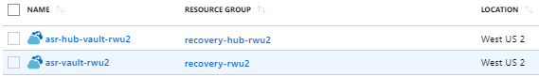

All production VMs are replicated to Disaster Recovery (DR) Site WestUS2 from EastUS2.

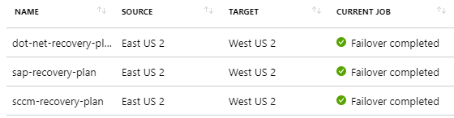

Dotnet-replication-group protects all dotnet based applications.

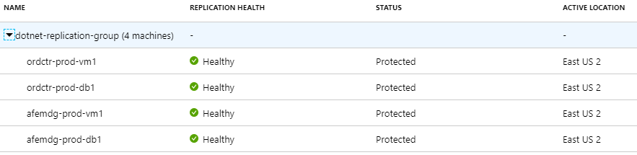

All Sap Production VMs are protected in SAP-RECOVERY-PLAN.

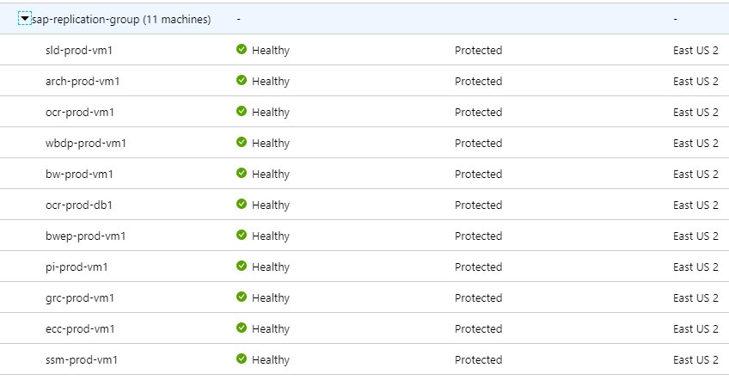

On sccm-recovery-plan SQL and SCCM servers are protected.

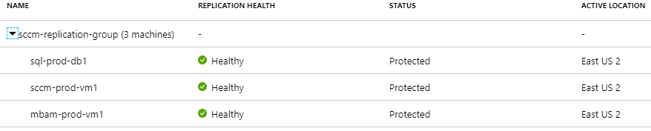

All production VMs will be replicated in a Recovery Vault in West US 2. If a disaster strikes in East US 2, all VMs in the vault will be failed over to West US 2, the DR site. In addition to replicating production VMs, there are a few more steps required before recovery is possible in the DR VNET.

* The applications that use SQL Server must be set up in a three node Always-on configuration, with the third asynchronously replicated node in West US 2
* SAP HANA databases will be configured for HANA System Replication (HSR) to replicate the HANA database in West US 2
* HANA System Replication is configured to replicate from Primary HANA VM to secondary HANA VM in East US 2 and secondary HANA VM has HSR to DR HANA VM in West US 2
* Traffic Manager must be configured to re-route to the DR application endpoints

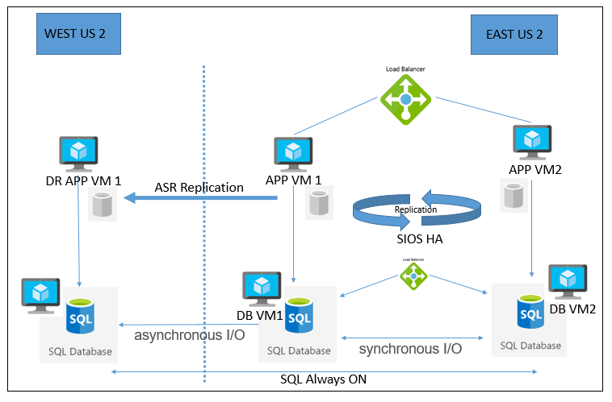

Traffic Manager uses DNS to direct client requests to the most appropriate endpoint, based on a traffic-routing method and the health of the endpoints. For DR, Priority traffic-routing will be configured. DR Failover will be initiated manually. The DR endpoints will be disabled during normal operations and enabled during a DR Failover.

Livent will monitor the entire primary Production site in East US 2 and will determine if the site is unavailable. They will escalate to Microsoft if Microsoft has not already and jointly determine whether a DR Failover is required within the appropriate time to allow for a full restoration of the high-availability applications in West US 2.

When a failover is initiated, the VMs are created in the target resource group, target virtual network, target subnets, and in the target availability set. During a failover, any recovery point can be used. The diagram illustrates that ASR restores the VMs, data disks, availability sets, and load balancers in the DR site. ASR will not restore the databases but will be continuously replicated as previously noted. A manual process to set up the DR database as primary nodes is required. When the primary site is restored, the databases will automatically update themselves in the primary site.

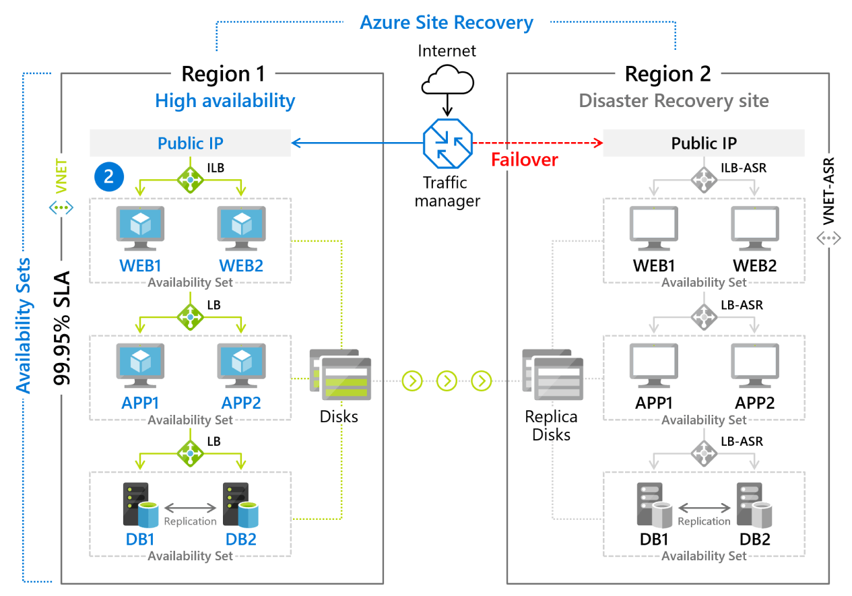

# SQL Server Database Disaster Recovery

Livent will use SQL Server three node always-On to continuously replicate production data asynchronously to the DR site. This will eliminate the need to fail over the production databases.

For standard non-high availability scenario, Livent will use SQL Server File-snapshot backup for quicker restores of database files stored in the Azure Blob storage service.

# SAP HANA System Replication (HSR)

As with SQL Server Always-ON, one of the advantages of the HSR methodology is that it replicates SAP HANA data directly from the source to another database. You can use this separate database as the primary one in case of a failover, as it contains the exact same information from the SAP HANA database.

As the SAP and non-SAP application VMs failover to the DR site, they can quickly connect to the HANA or SQL Database instances to meet the required SLAs in the table below.

|  |  |  |
| --- | --- | --- |
| **Service Level Element** | **Description** | **Service Level** |
| **Recovery Time Objective (RTO)** | The RTO defines the maximum period expected to restore services in the event of a failure | < 2 hours for all production systems (excluding SAP HANA) |
| **Recovery Point Objective (RPO)** | The RPO defines the maximum amount of data loss allowed in the event of a failure, measured in time | < 20 minutes for all production systems (excluding SAP HANA) |

# Storage Component Details

|  |  |  |  |  |  |
| --- | --- | --- | --- | --- | --- |
| Storage Name | Description | Type | Replication | Region | Resource Group |
| appgrpzscalerreu2diag | Diagnostics ZScaler REU2 | Storage | LRS | East US 2 | appgrp-zscaler-reu2 |
| appgrpzscalerrwu2diag | Boot Diagnostics | Storage | LRS | West US 2 | appgrp-zscaler-rwu2 |
| csg08886d3b0420x49bex9a5 | Cloud Shell | StorageV2 | LRS | Central India | cloud-shell-storage-centralindia |
| bsv5omasrvaultasrcache | ASR | Storage | LRS | West US 2 | recovery-reu2 |
| j9ml0vasrvaultasrcache | ASR | Storage | LRS | West US 2 | recovery-rwu2 |
| kte34masrhubvaasrcache | ASR | Storage | LRS | East US 2 | recovery-hub-rwu2 |
| Proddbbackupstoragetest | SQL Backups | StorageV2 | LRS | East US 2 | vm-dev-sql-db-reu2 |
| q8uektasrvaultasrcache | Logs | Storage | LRS | East US 2 | recovery-rwu2 |
| stordiskrestorereu2grs | HANA and SQL Backup | StorageV2 | GRS | East US 2 | storage-restore-disks-reu2 |
| stordiskrestorerwu2grs |  | StorageV2 | GRS | West US 2 | storage-restore-disks-rwu2 |
| stormonlogdrrwu2lrs | Barracuda FW backup, boot diag logs and insight logs of NSG | StorageV2 | LRS | West US 2 | storage-monlog-dr-rwu2 |
| stormonloghubreu2lrs | Barracuda FW backup, boot diag logs and insight logs of NSG | StorageV2 | LRS | East US 2 | storage-monlog-hub-reu2 |
| stormonlognonprodreu2lrs | Storing boot Diag logs | StorageV2 | LRS | East US 2 | storage-monlog-nonprod-reu2 |
| stormonlogprodreu2lrs | Storing boot Diag logs | StorageV2 | LRS | East US 2 | storage-monlog-prod-reu2 |
| storscriptsreu2lrs | Storing Scripts and Diag log | StorageV2 | LRS | East US 2 | storage-all-scripts-reu2 |
| storsqldatareu2lrs | Storing SQL Data | StorageV2 | LRS | East US 2 | storage-sqldata-rwu2 |

# Risk Register

Attached Audit Report.



cid:image001.png@01D55DCE.799212C0

# Security

The following are the security requirements as provided by Livent and FMC.

# Network Design

The network must contain at least 3 zones that are separated by “firewalls”

1. The network must contain at least 3 zones that are separated by “firewalls”
   * + an internet-facing zone (DMZ) for access to/from the internet (does not require 2-factor authentication)
     + an application/middleware zone (requires 2-factor authentication within the past 8 hours)
     + a "Secure"/database zone (requires 2-factor authentication within the past 8 hours)
2. There is NO direct access to the internet from either the application/middleware zone or the Secure/database zone. Access is via the Livent network.

As of today, only Barracuda Firewall on DR and ELB device has access to public internet.

# Identity, Access and Authorization

1. Access to Livent systems/applications residing in the “Secure”/database zone and the application/middleware zone will require 2-factor authentication for all Livent personnel and for all personnel supporting/accessing Livent production systems.
2. Users will obtain authorization to use the systems using the standard Livent myAccess process. User access to systems must be approved by the data/application owner prior to granting access.
3. Termination of access to Livent will result in immediate/swift termination of access to the Livent systems.

Note: Process has to be defined for user access management include VM, VPN and portal access.

# Encryptions

* + - 1. All backups of data in production will be encrypted
      2. All data in transit will be encrypted, including data contained in or retrieved via database calls.
      3. The SQL server databases used in the secure zone will be encrypted using SQL server encryption.

# Firewall Design

Livent has Barracudas to serve the Firewall needs it serves both as Web Application Firewall and Next-Gen Firewall Device.

The Next gen firewall and the web application firewalls which work in conjunction to provide the necessary protection from L3 all the way to L7 to safeguard the components of the cloud. They provide additional functionality of SSL inspection, decryption, AV, advanced threat protection and VPN functionality.

# Next Gen Firewall

Livent has Barracuda to serve the Firewall needs. While Azure does provide a Next-gen firewall and a WAF.

Next-generation firewalls typically have many features some of which that are recommended to be deployed are as follows:

1. High Availability
2. Cloud Scalability
3. Traffic filtering
4. SNAT and DAT support
5. URL redirection
6. DoS attack prevention
7. DDoS attack prevention
8. SYN Flood attack protection
9. ICMP flood protection
10. Logging and Monitoring
11. SSL Encryption and decryption
12. SSL Inspection.

|  |  |  |
| --- | --- | --- |
| CI Name | Private IP | Vnet |
| fw-hub-vm01 | 10.250.250.52 | vnet-core-services-reu2 |
| fw-hub-vm02 | 10.250.250.53 | vnet-core-services-reu2 |
| fw-dr-vm01 | 172.20.18.36 | vnet-dr-rwu2 |

# Web Application Firewall

Livent has configured Barracuda to serve as Web Application Firewall device.

Barracuda has configured in HA mode along with same vendor’s Next-gen Firewall. Web Application firewall protects.

1. **Protection from common, high-visibility attacks** – SQL injection, Cross Site Scripting, Command injection, CSRF, XML attacks, Antivirus protection
2. **Protection from attacks based on session state** – Session Hijacking, cookie tampering, clickjacking
3. **Brute Force attack Prevention**
4. **Application denial of service (DoS) protection** – Slow client attacks, DDoS Prevention using CAPTCHA, BOT attack prevention,
5. Protection from volumetric and application DDoS attacks using DDoS Protection
6. **Data Theft Protection** – Deep inspects all server responses to prevent leakage of sensitive information using provided default patterns (credit card data, social security numbers, etc.) or User Defined Patterns (Custom Patterns).
7. **Website Cloaking** – Strips identifying banners and version numbers from web server software and provides customizable HTTP error handling to defeat server fingerprinting attacks (suppressing error codes and filtering headers).
8. **Access Control** – Form and Basic Authentication and Single Sign On with integrations into LDAP.
9. **Application Delivery** – Load Balancing, Caching and Compression, SSL Offloading, Rate Control
10. **Logging, Reporting and Monitoring** – Inbuilt reporting module, Web Firewall Logs, Access Logs, Audit Logs, Configuring Syslog.

Next-gen firewalls in HA mode for any public facing traffic at the egress points. This being backed by a WAF pair for L7 protection. The FWs protect all out bound traffic by routing all traffic from all VNET Subnets via a UDR to the Next- gen firewall internal load balancer.

|  |  |  |
| --- | --- | --- |
| CI Name | Private IP | Vnet |
| waf-dr-vm1 | 172.20.18.52 | vnet-dr-rwu2 |
| waf-hub-vm01 | 10.250.250.68 | vnet-core-services-reu2 |
| waf-hub-vm02 | 10.250.250.69 | vnet-core-services-reu2 |

# MFA – Multi Factor Authentication

MFA is enabled for all non-hybrid connections. – Azure AD MFA

cid:image001.png@01D55DCE.799212C0

# Server Patch Management

Patch management process is now scheduled on quarterly basis.

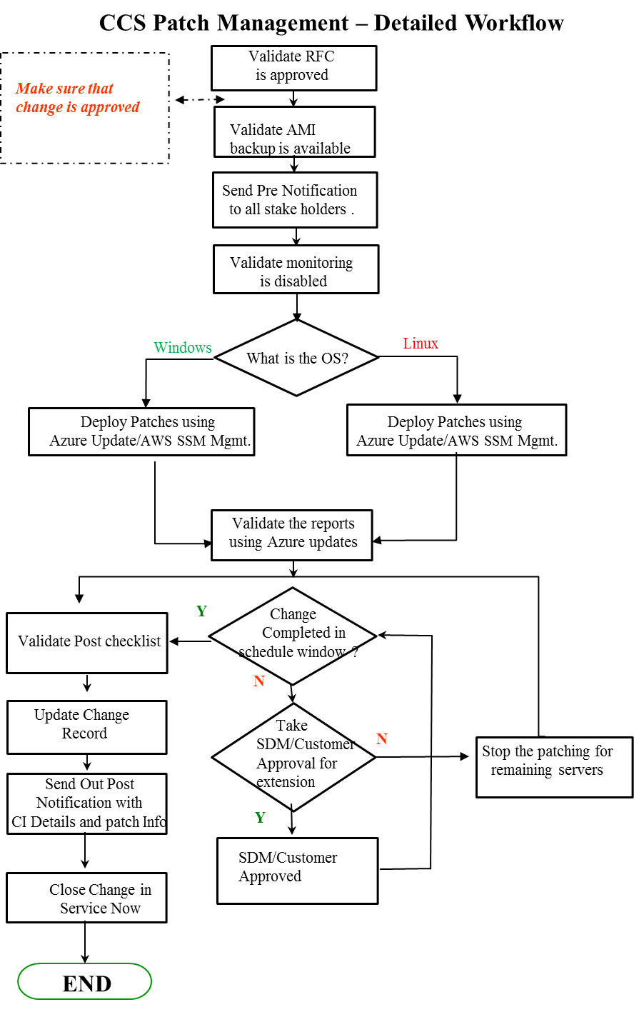

# Maintenance Window

* **Dev, QA and Sand Box**
* Every month at 2nd Saturday at 11 PM Saturday to 5 AM Sunday EST.
* **Production**
* Every quarterly of 3rd Saturday at 11 PM Saturday to 5 AM Sunday EST.
* **Domain Controllers** will be taken care by System Owner/Livent.



# Backup Management

# VM Backup

CMS writes backups to an Azure Blob Storage Account.

For highest level of protection, the backup Blob Storage Account will be Read-Access Geo Redundant (RA-GRS) and The Retention policy for backups will be 15 days.

Backups will be daily at 07:00 UTC to prevent business operations impact.

CMS restores backups to same VM. There is an option available to restore to a different computer.

|  |  |
| --- | --- |
| Policy Items | Value |
| Backup Frequency | Daily |
| Time | 2 EDT (07:00 UTC) |
| Time Zone | *Eastern US* |
| Retention | 15 Days |

Backup Recovery Vault Details.

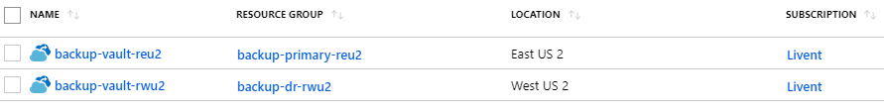

All VM’s, production and non-production, have a daily VM snapshot backup scheduled to the Backup Vault.

All SQL Backups are scheduled using Azure Backup Service. This includes full daily database backups for all development, test and production databases. Transaction log backups are also configured for all databases.

Full HANA database backups are scheduled once a day with hourly increments. All HANA backups are available in the Backup Vault as part of the VM snapshot.

Backup failures are monitored, and email alerts generated as part of the Azure monitoring setup.

|  |  |  |  |  |  |  |
| --- | --- | --- | --- | --- | --- | --- |
| **S.No** | **Resource** | **Policies** | **Location** | **Schedule** | **Retention** | **Description** |
| 1 | Virtual Machine | LiventSAPVirtualMachines | West US 2 | Daily10:00 PM UTC | Retain snapshots for 2 days, Daily backups 15 days and Weekly Saturday at 10:00 PM for 2 weeks | DR Firewall DR WAF DR Sharepoint & DR Sharepoint Data |
| 2 | Virtual Machine | LiventADDS | West US 2 | Daily 6:00 PM UTC | Retain snapshots for 2 days, Daily backups 15 days and Weekly Saturday at 06:00 PM for 2 weeks | SAP Server on DR |
| 3 | Virtual Machine | LiventNonSAPVM | West US 2 | Daily 7:30 PM UTC | Retain snapshots for 2 days, Daily backups 15 days and Weekly Saturday at 07:30 PM for 2 weeks | DR DC Server |
| 4 | Virtual Machine | LiventADDs | East US 2 | Daily 06:00 PM EST | Retain snapshots for 2 days, Daily backups 15 days and Weekly Saturday at 06:00 PM for 2 weeks | DC Server |
| 5 | SQL | SQLsysDBProd | East US 2 | Daily 11:00 PM EST | Retain 15 days | Master and msdb Database |
| 6 | Virtual Machine | LiventProdNonSAPVM | East US 2 | Daily 6:00 PM EST | Retain snapshots for 2 days, Daily backups 15 days and Weekly Saturday at 06:00 PM for 2 weeks | NonSAP Server on Prod |
| 7 | Virtual Machine | LiventDevNon | East US 2 | Daily 2:00 AM EST | Retain snapshots for 2 days,  Daily backups 15 days and Weekly Saturday at 2:00 PM for 2 weeks | NonSAP Server on Dev |
| 8 | SQL | SQLWeeklyFullProd | East US 2 | Weekly 5:30 AM EST | Weekly full on Saturday 5:30 AM 2 Weeks, Differential Backup except Saturday 7:00 PM with 14 days, T logs every 15 minutes 14 days | SQL Prod Workloads |
| 9 | Virtual Machine | LiventSAPVirtualMachines | East US 2 | Daily 6:00 PM EST | Retain snapshots for 2 days,  Daily backups 15 days and Weekly Saturday at 06:00 PM for 2 weeks | SAP VMs on Prod |
| 10 | SQL | SQLDevDBBackup | East US 2 | Daily Full 01:00 AM EST | T log Backup every 1 hour retain 15 days | SQL Dev DBs |
| 11 | SQL | SQLProdDBBackup | East US 2 | Daily Full 08:00 PM EST | T log Backup every 1 hour retain 15 days | SQL Prod DBs |
| 12 | SQL | SPSQLProdDB2AMEST | East US 2 | Daily Full 02:00 AM EST | T log Backup every 1 hour retain 15 days |  |
| 13 | SQL | SPSQLProdDB1 | East US 2 | Daily Full 11:00 PM EST | T log Backup every 1 hour retain 15 days |  |
| 14 | SQL | SPSQLProdDB4AMEST | East US 2 | Daily Full 04:00 AM EST | T log Backup every 1 hour retain 15 days |  |
| 15 | SQL | SQLDevSysBackup | East US 2 | Daily Full 05:00 AM EST | T log Backup every 1 hour retain 15 days | Master and msdb DBs |

# Approval and Communication

We will be uploading related Approval emails and Communication emails template once those are discussed and reviewed with Application/System owner.

# Type of Update

1. The following categories of updates are included in this service:

|  |  |  |  |  |  |  |
| --- | --- | --- | --- | --- | --- | --- |
| **MS Product** | **Critical Updates** | **Security Updates** | **Updates** | **Definition Update** | **Update Rollups** | **Service Packs** |
| **Windows 2012** | YES | YES | YES | N/A | YES | NO |
| **Windows 2012 R2** | YES | YES | YES | N/A | YES | NO |
| **Windows 2016** | YES | YES | YES | N/A | YES | NO |

Note: - .Net and Windows Defender patch will need to take care by respective application team.

1. The Microsoft Update Classification descriptions are as follows:

|  |  |
| --- | --- |
| **Update Classification** | **Description** |
| Critical updates | Broadly released fixes for specific problems addressing critical, non-security related bugs. |
| Security updates | Broadly released fixes for specific products, addressing security issues. |
| Updates | Broadly released fixes for specific problems addressing non-critical, non-security related bugs. |

Note: - Vulnerabilities scan process and procedure need to be shared with Cloud Team.

# Antivirus Management

Symantec Endpoint protection is being used for Endpoint Protection.

# Active Directory and DNS Server Management

Livent will have a redundant pair of domain controllers (DCs) in the West US 2 actively replicating with on-premises DCs in the same way as in East US 2. If East US 2 suffers an outage, all replicated VMs in West US 2 will be automatically joined to the Liventworld domain as part of the ASR failover process.

The current design calls for a pair of domain controllers in East US 2. For additional protection against DC outages in East US 2, consider deploying an additional DC in the availability set with the other two. In the rare occasion where your primary DCs fail, Azure Backup with Windows System State Backups enabled. System State fully encapsulates Active Directory, which is the most important database in any organization and allows for targeted domain-controller recoveries.

|  |  |  |
| --- | --- | --- |
| DC Name | Resource Group | Location |
| addc-bkp-vm01 | vm-dr-addc-rwu2 | West US 2 |
| addc-bkp-vm02 | vm-dr-addc-rwu2 | West US 2 |
| adcon-prod-vm06 | vm-hub-aadcon-reu2 | East US 2 |
| addc-prod-vm04 | vm-hub-addc-reu2 | East US 2 |
| addc-prod-vm05 | vm-hub-addc-reu2 | East US 2 |

# AD Users

Livent On-Premises Active Directory Domain users are synchronized with the Livent AAD Tenant.

**Note: Once the SYNC is complete the connectivity will be removed between on premises to Azure.**

# AD Groups

Groups are created in Liventworld.com and then synchronized to the Azure environment via Azure AD Connect. Once these groups are established in Azure AD, they are then used for various RBAC assignments both on the Resource Groups and Subscription levels. There are two options for where to define and manage the accounts: 1. Leverage Azure Active Directory groups and allow those groups to write back to the source directory; 2. Define a partition/OU in the source forest with security groups and allow those groups to replicate to the cloud. These groups would be mapped to default roles in Azure. Roles will leverage on-premises Active Directory groups replicated to the cloud. Filters, rules and attributes will be adjusted to ensure that these groups are replicated. In the future, group write back will be enabled, if needed but manipulation of the directory will occur within the context of a Livent.com domain controller.

# Incident Management Process

Detailed information about the Incident Management process is attached for reference



# Change Management Process

Detailed information about the Change Management process is attached for reference.



# Problem Management Process/ RCA Process

Detailed information about the PM and RCA process is attached for reference.



# On-Boarding/Off-Boarding Process

Below document depicts the step by step process for

# Escalation Matrix

|  |  |  |  |  |
| --- | --- | --- | --- | --- |
| **Level** | **Name** | **Role** | **E-mail ID** | **Contact No.** |
|  |  |  |  |  |
| **Level** | **Name** | **Role** | **E-mail ID** | **Contact No.** |
|  |  |  |  |  |
|  |  |  |  |  |
|  |  |  |  |  |
|  |  |  |  |  |

# Vendor Management

This is managed at customer end only.

# Appendix

## Assessment Observations

Following are Assessment Observations reviewed with customer:

Well Architected Framework Review

Known Issues and related SOPs (Standard Operating Procedures)

Application Deployment Architecture

cid:image001.png@01D55DCE.799212C0